S.V. ARTS COLLEGE TIRUPATI

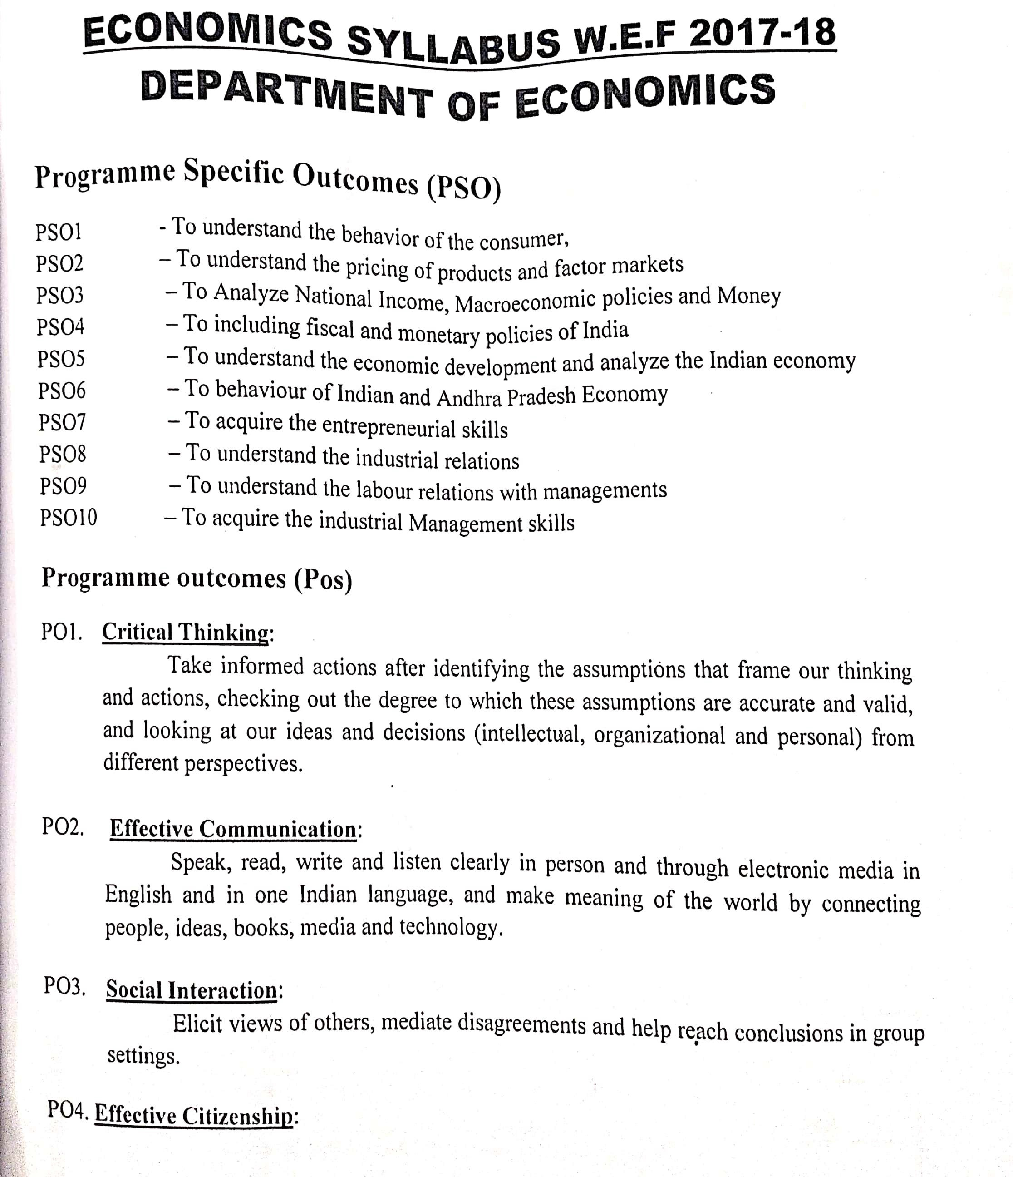

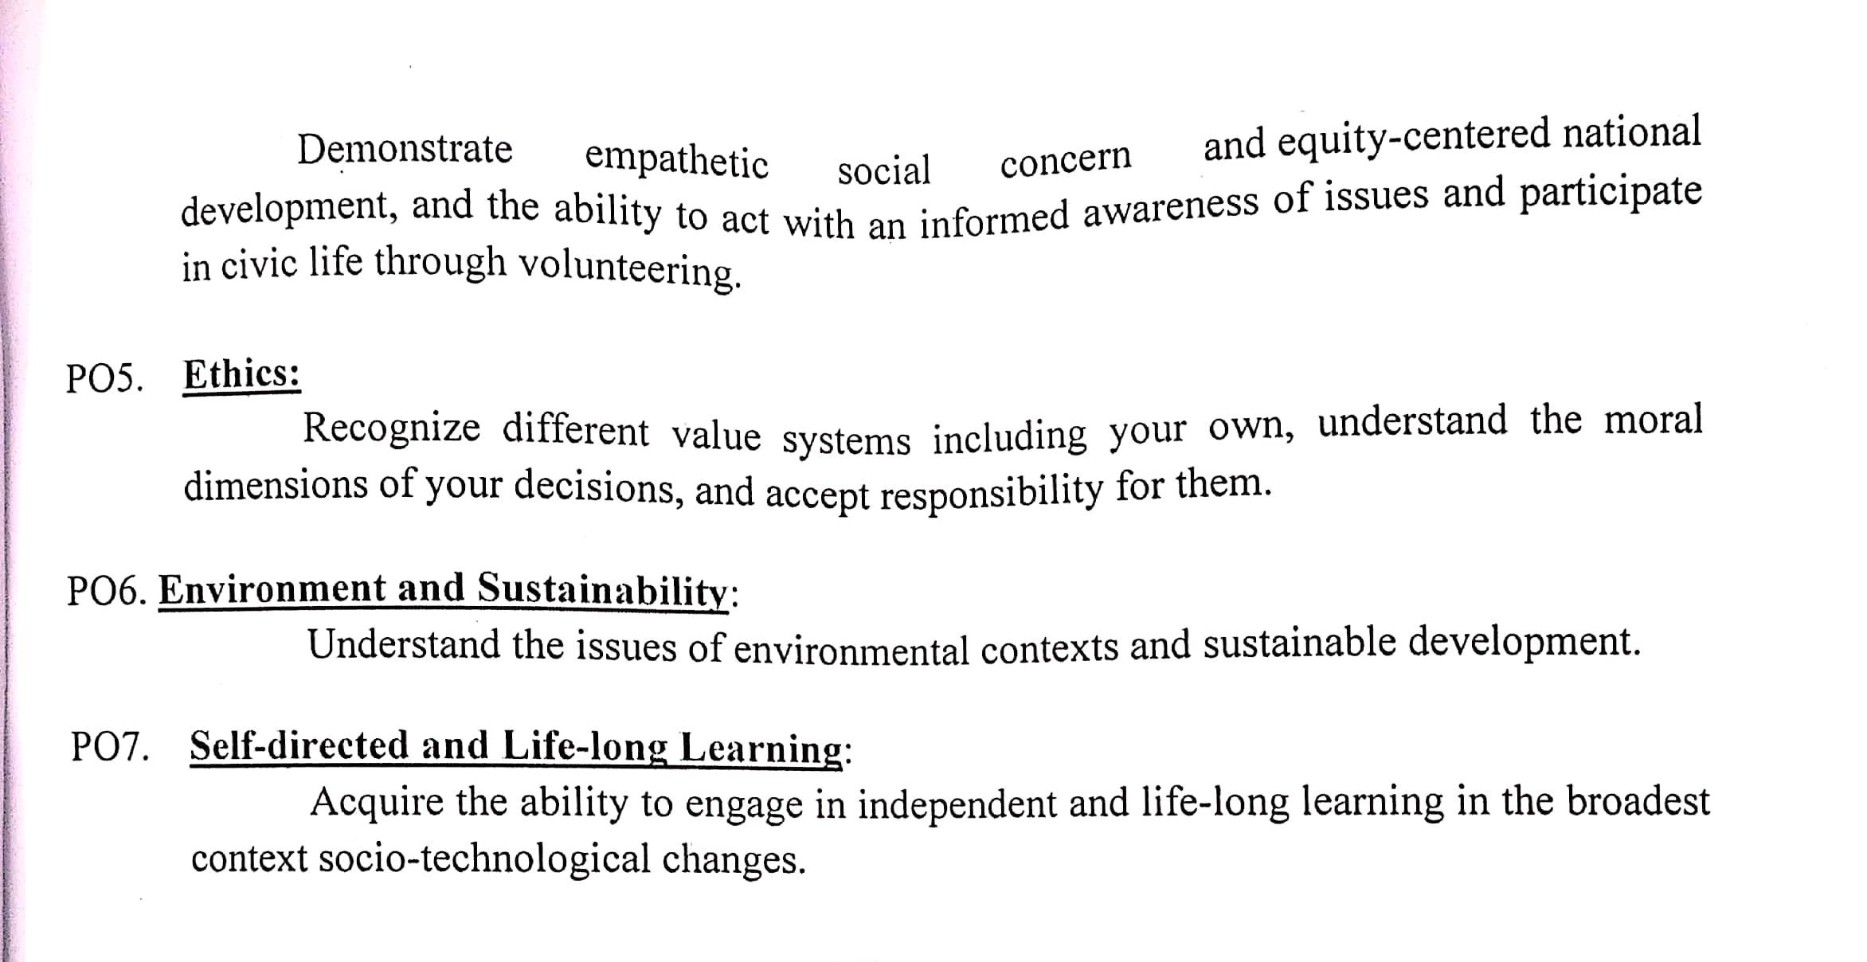

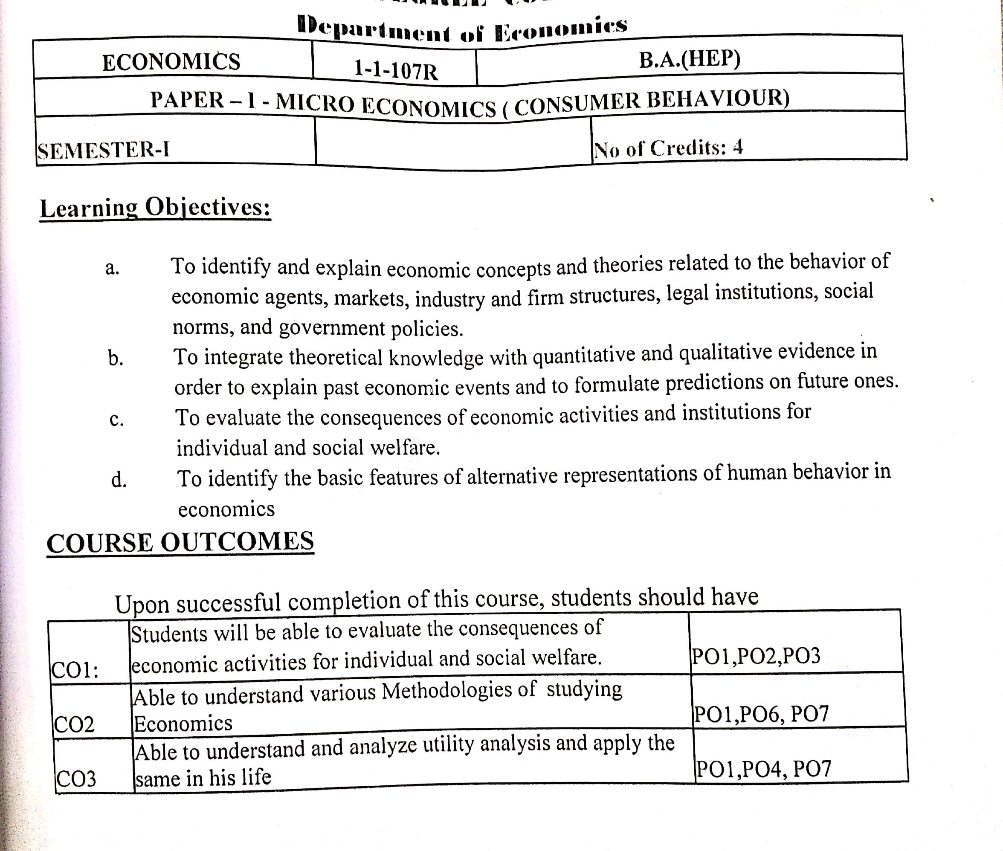S.V. ARTS COLLEGE TIRUPATI

DEPARTMRNT OF ECONOMICS
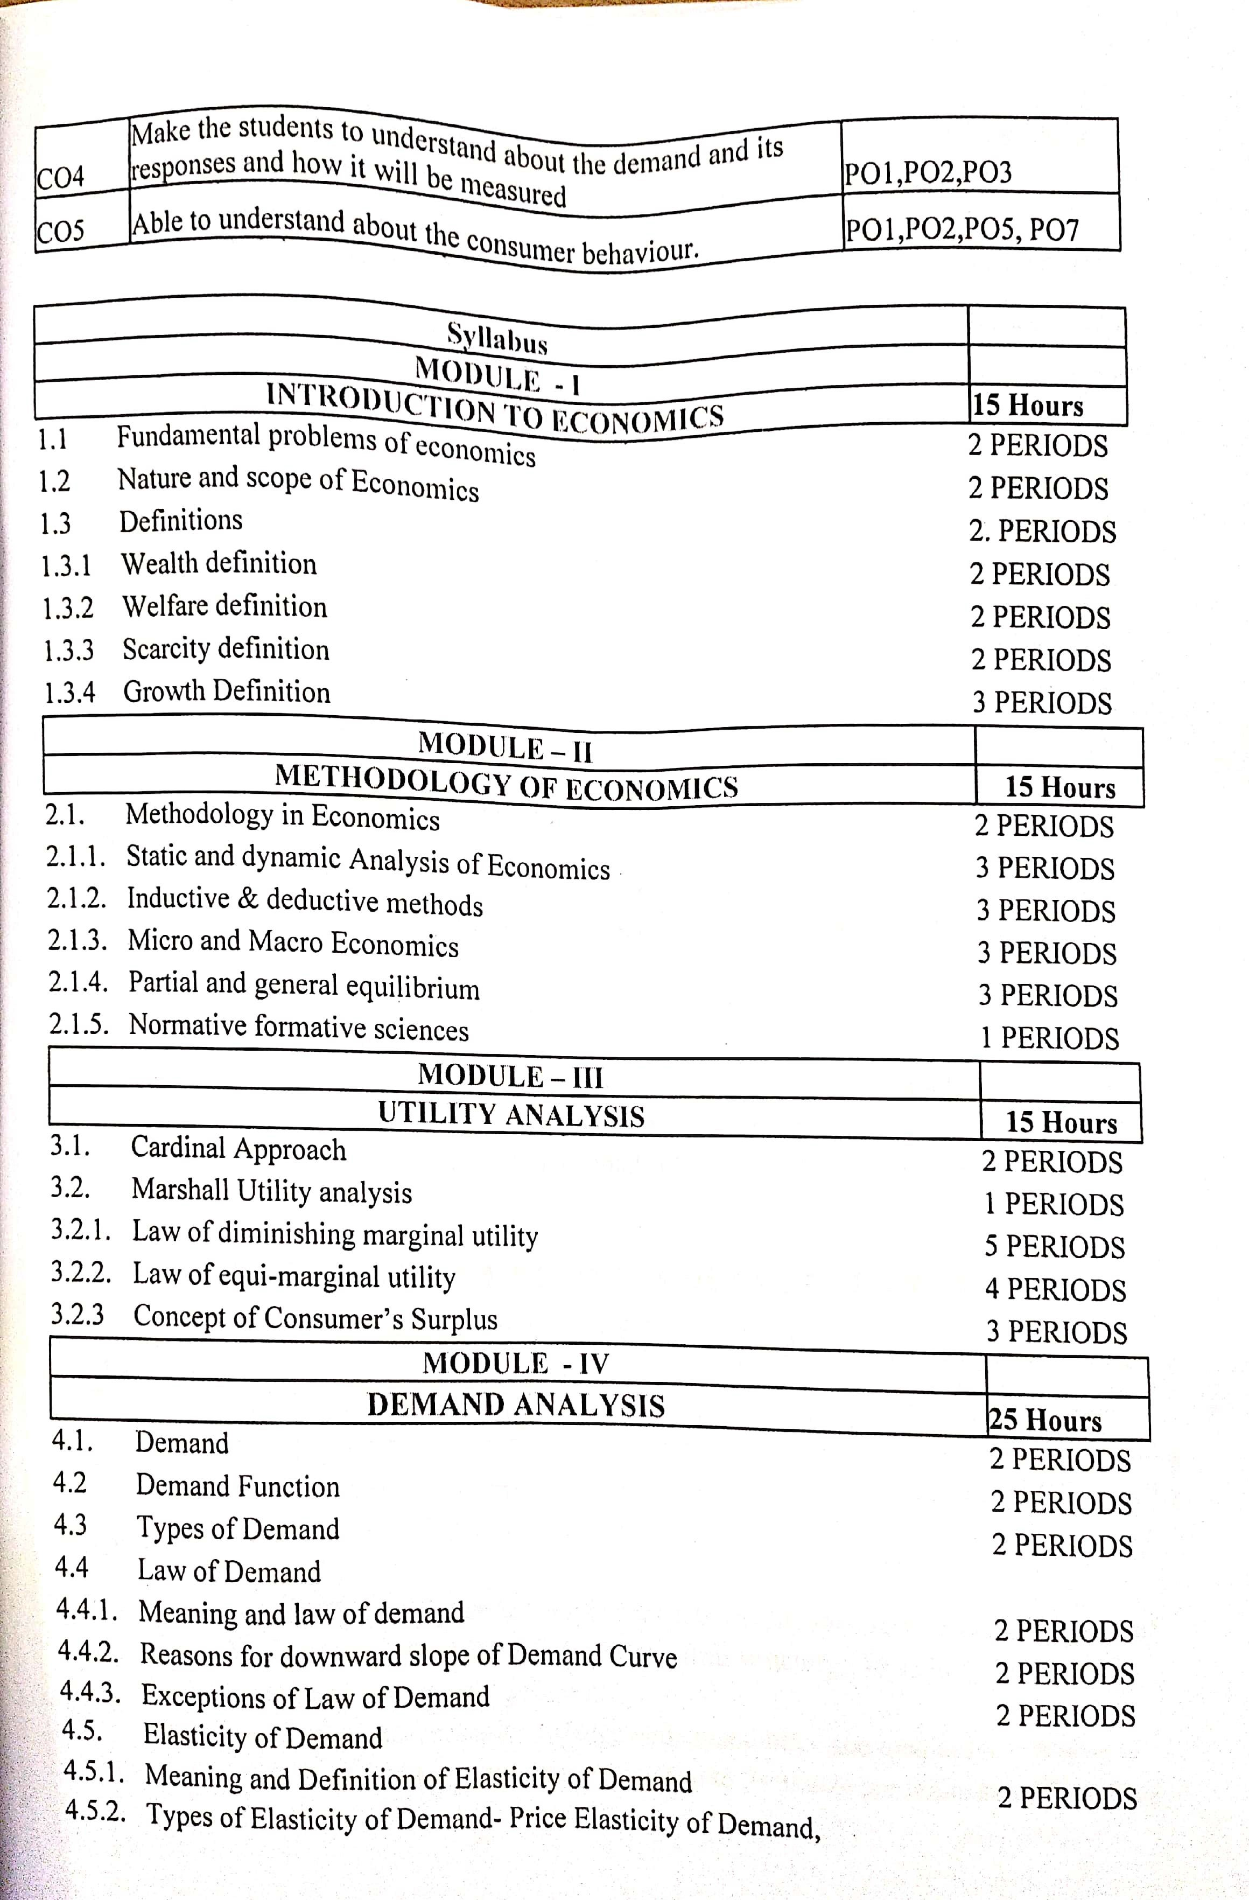

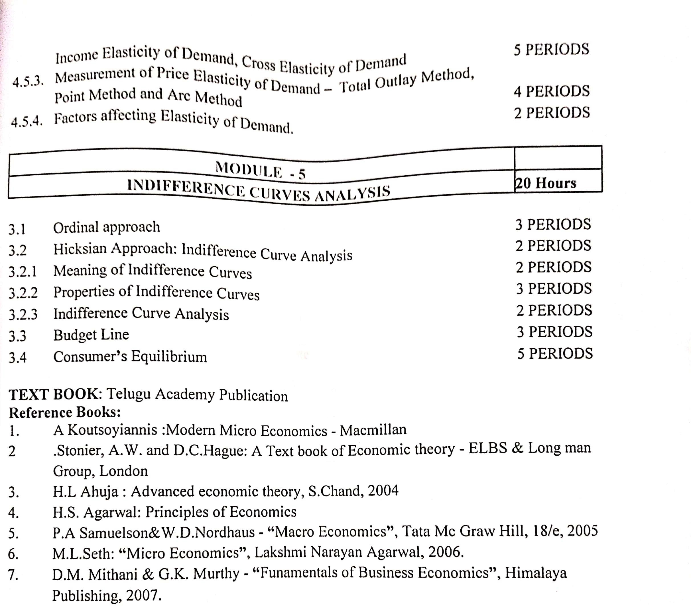

S.V. ARTS COLLEGE TIRUPATI

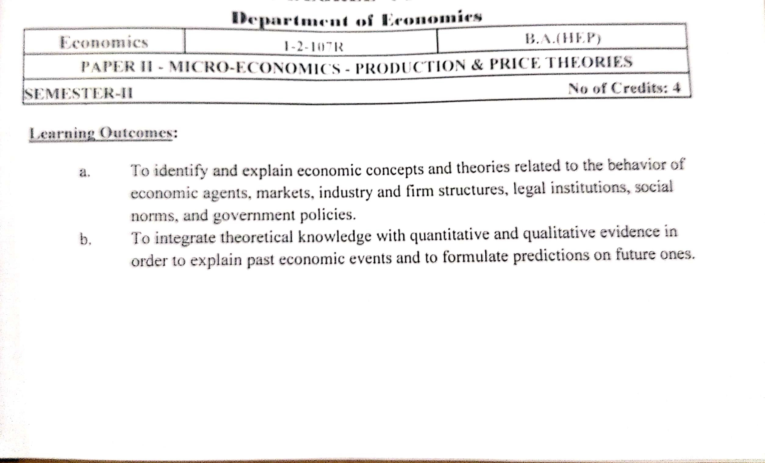DEPARTMRNT OF ECONOMICS

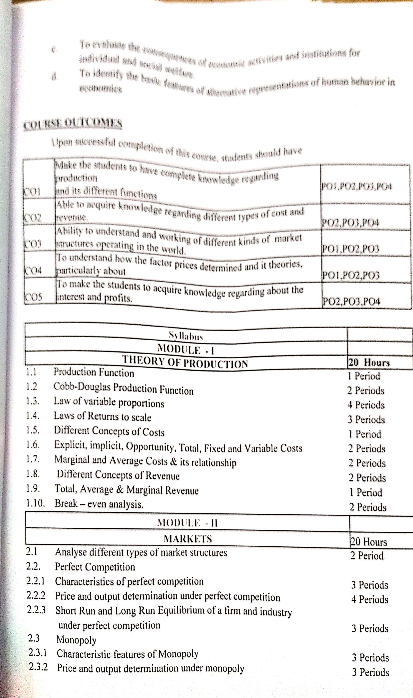

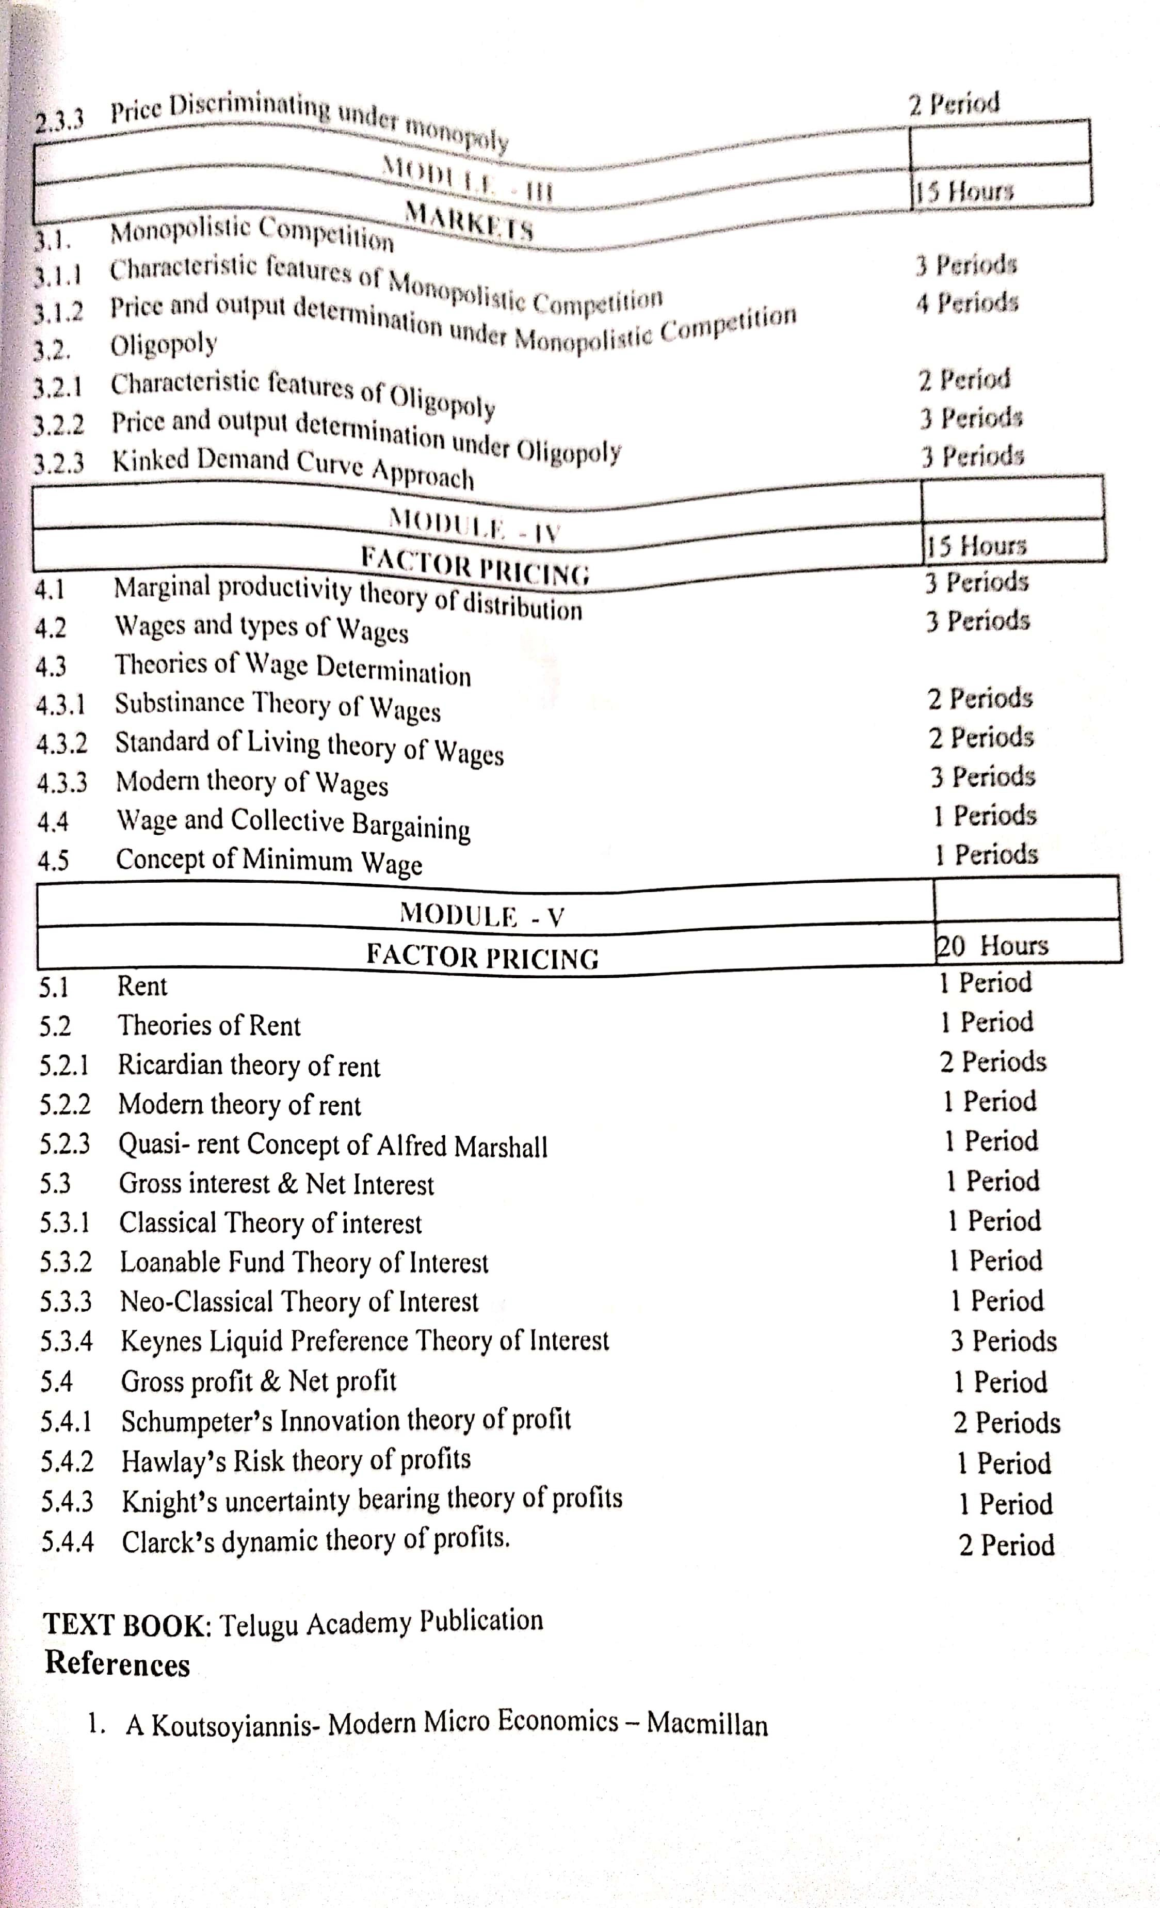

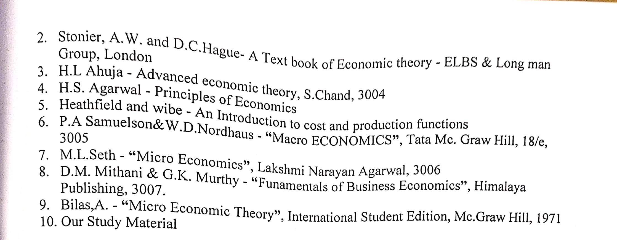

S.V. ARTS COLLEGE TIRUPATI

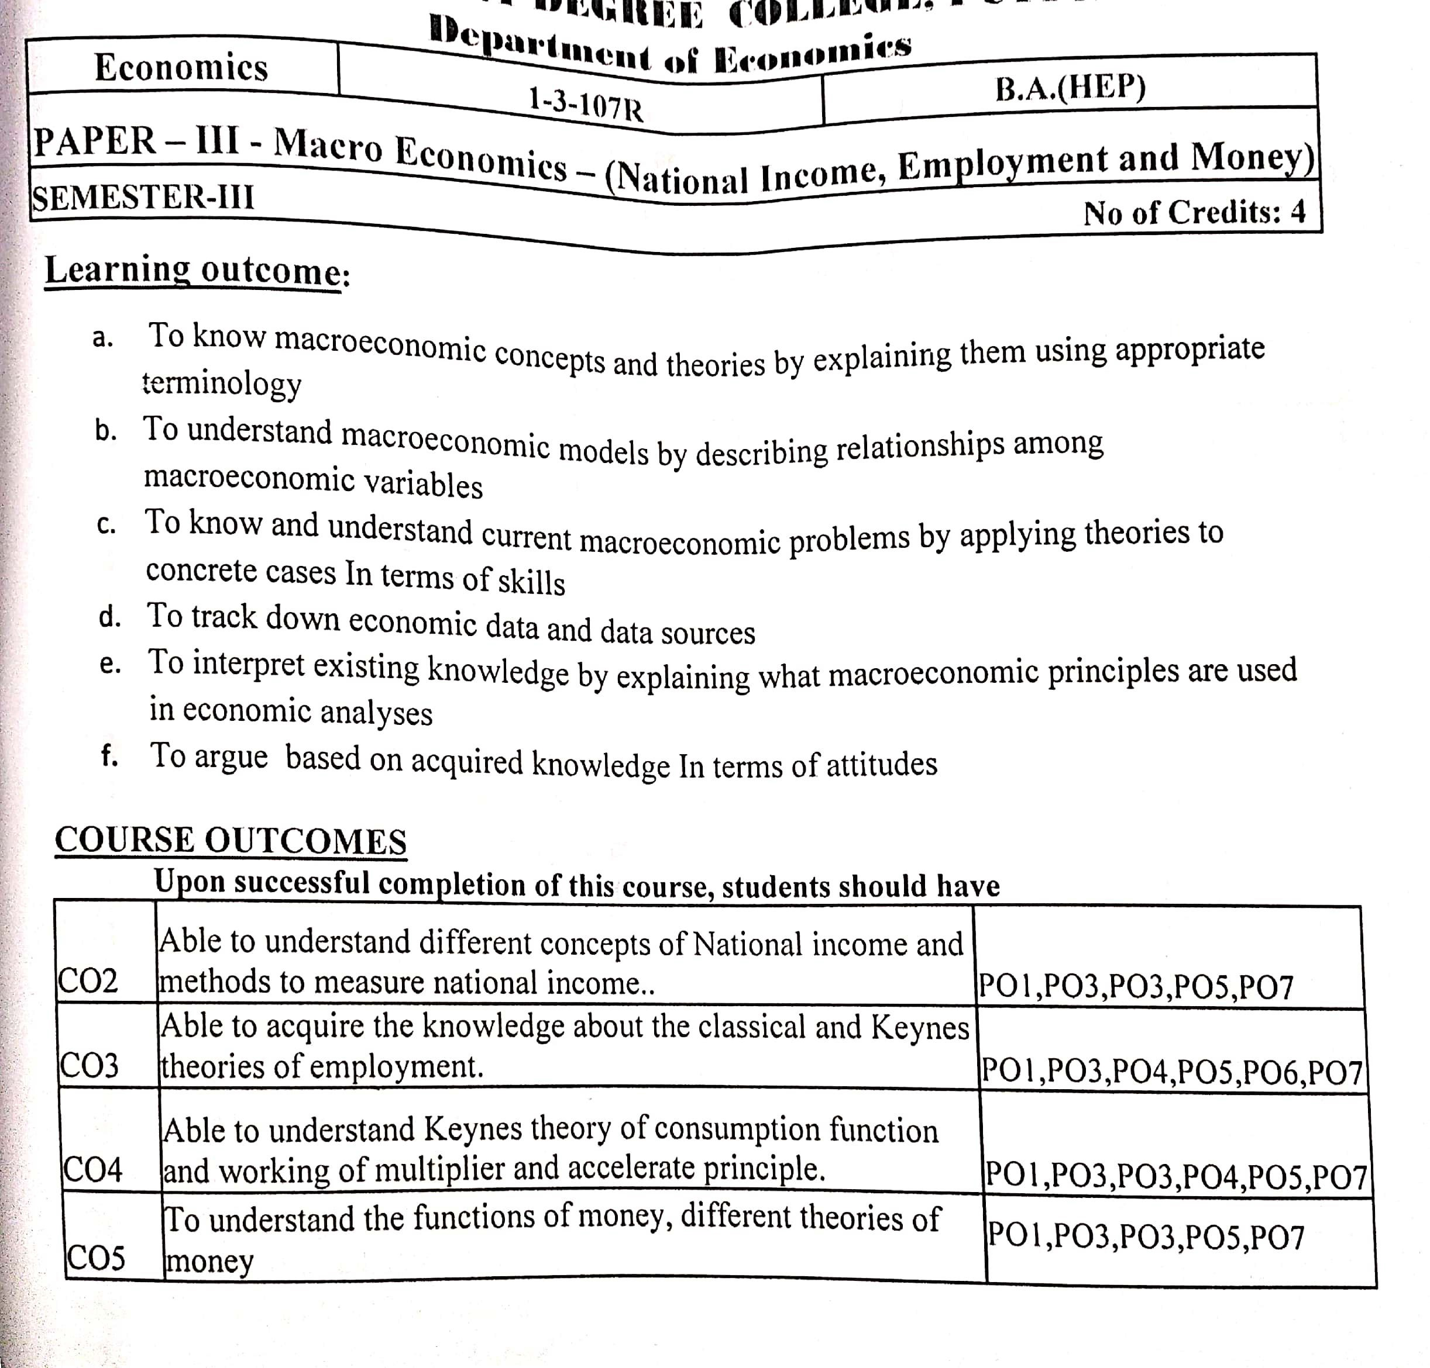DEPARTMRNT OF ECONOMICS
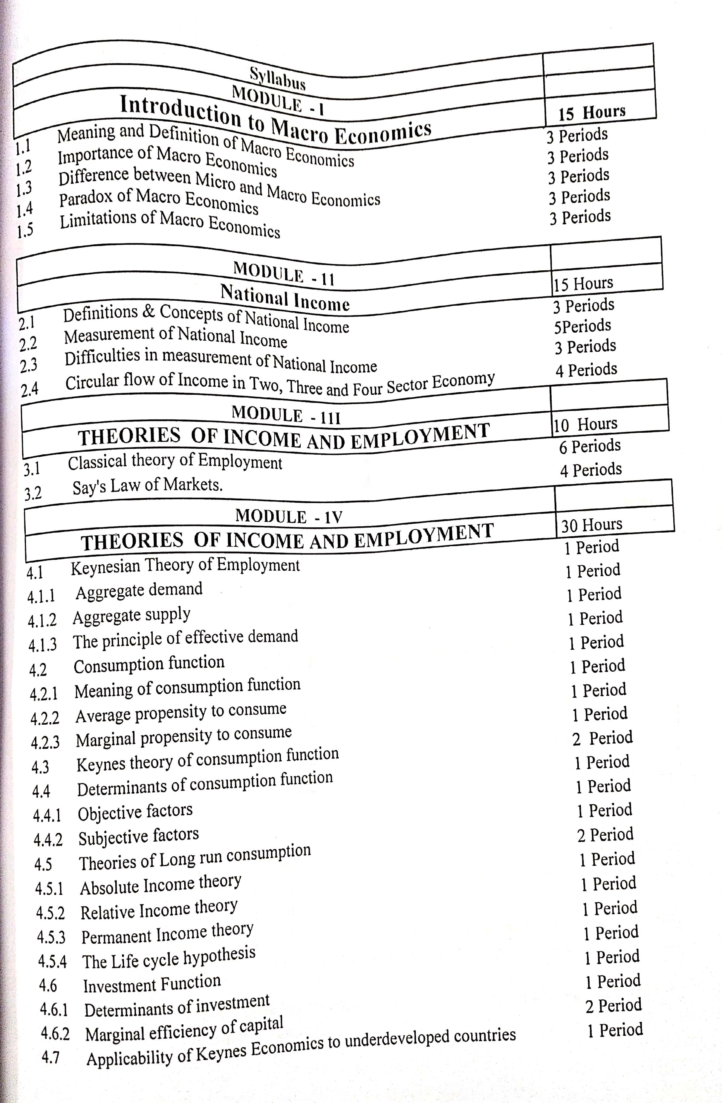

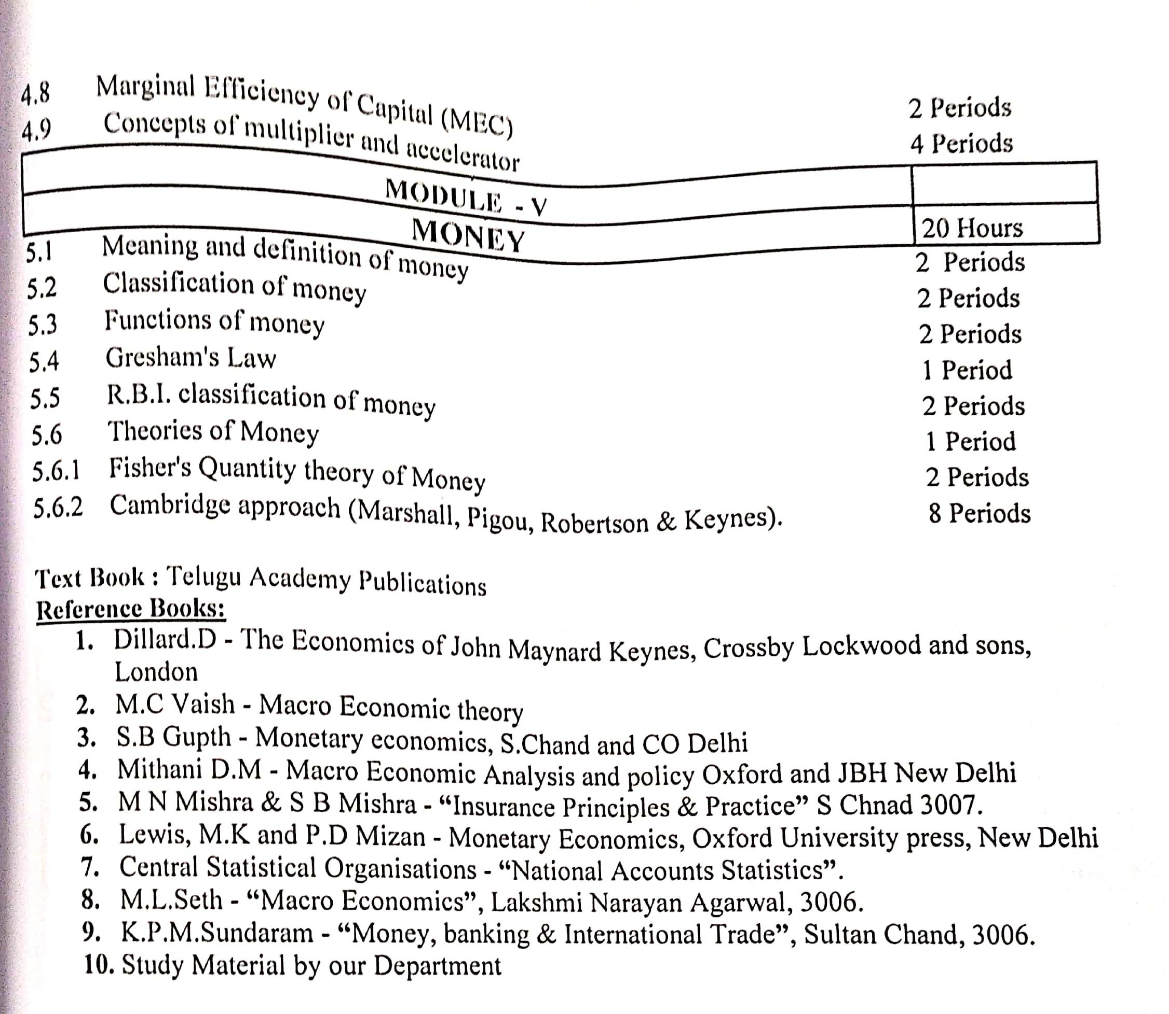

S.V. ARTS COLLEGE TIRUPATI
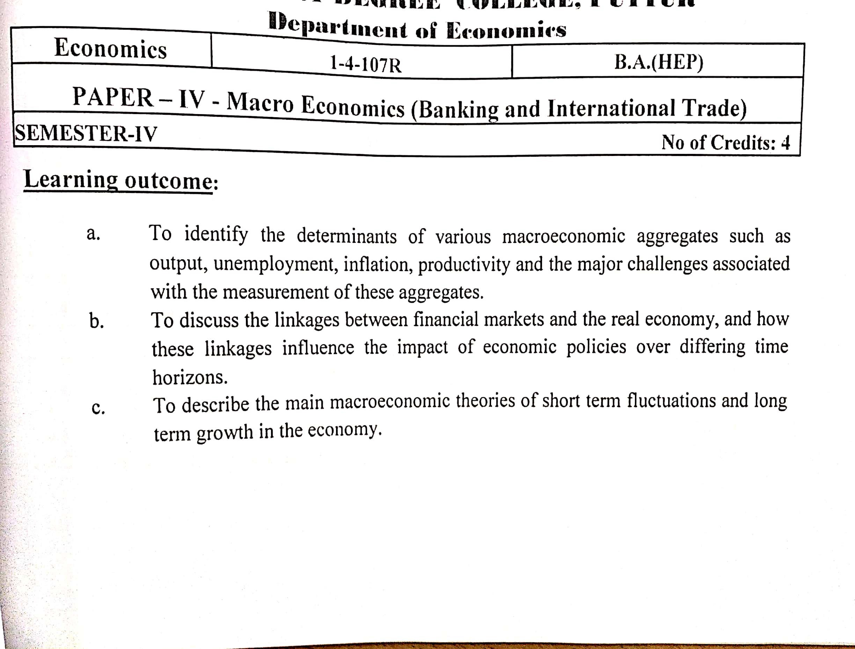DEPARTMENT OF ECONOMICS
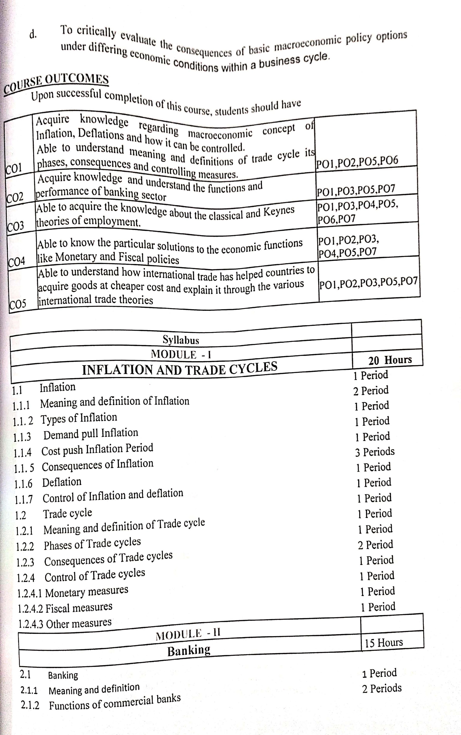

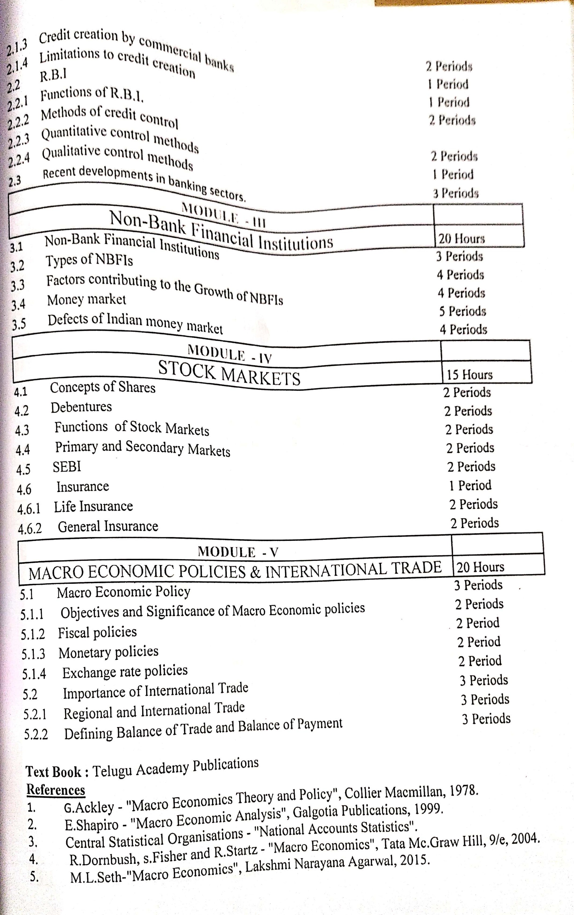

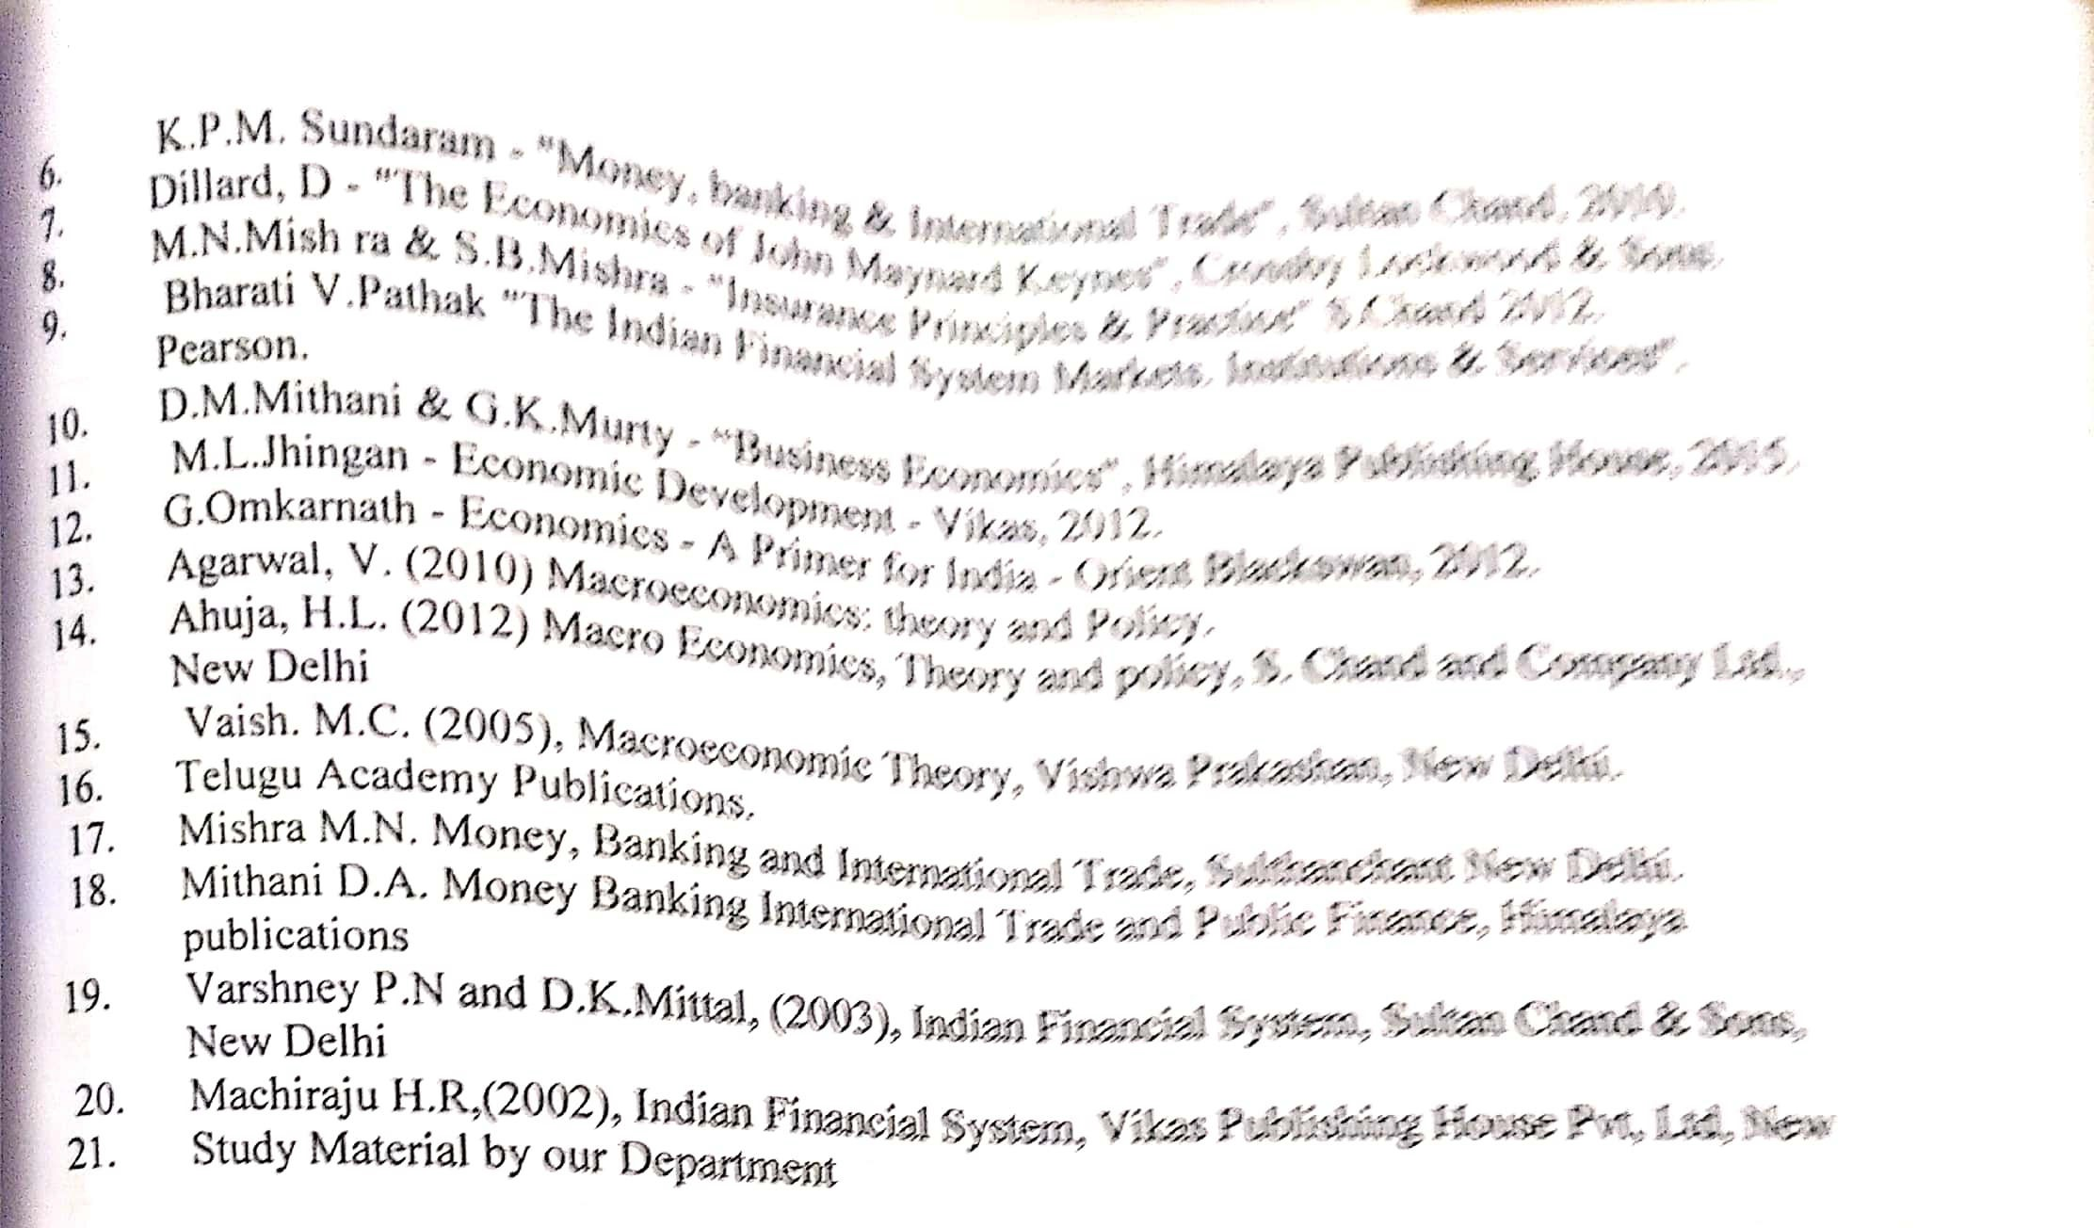

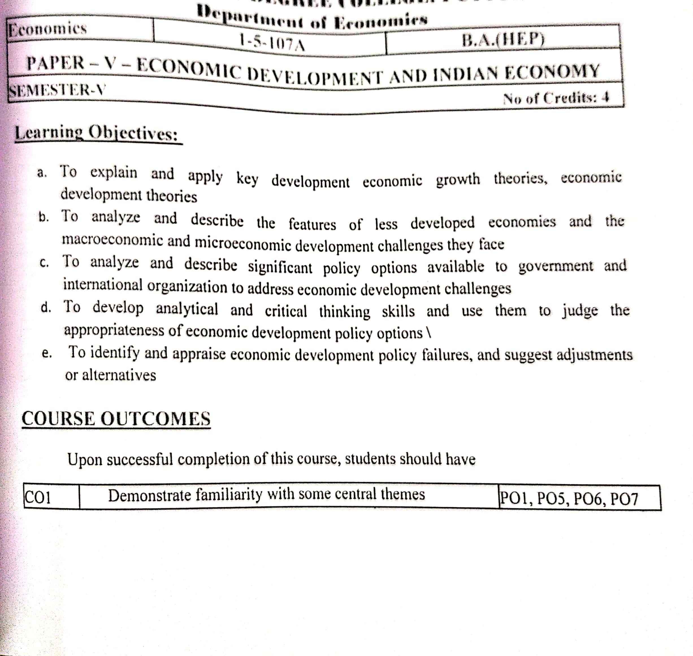S.V. ARTS COLLEGE TIRUPATI
DEPARTMENT OF ECONOMICS
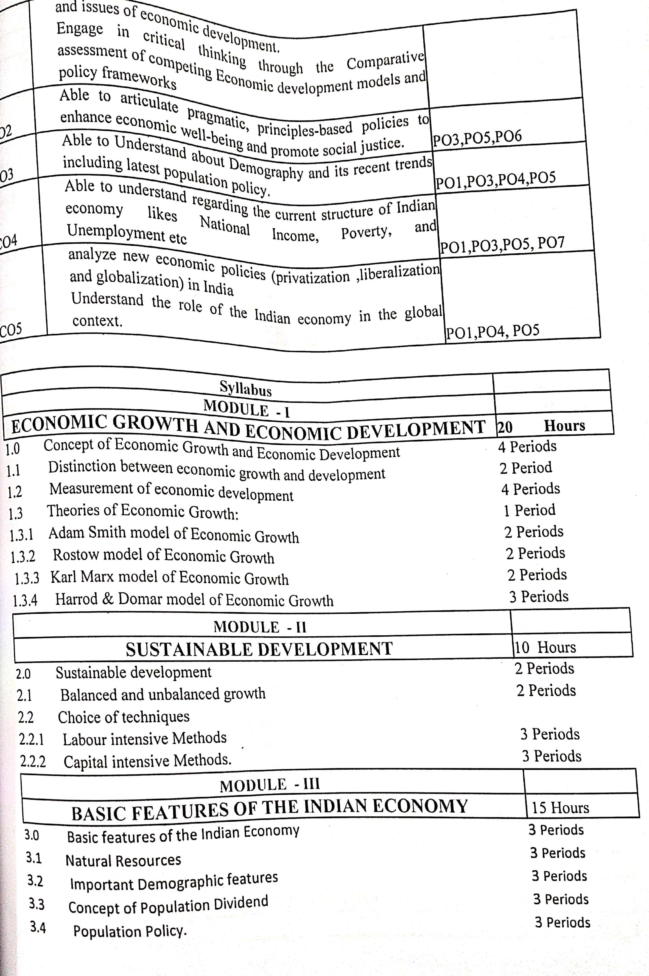

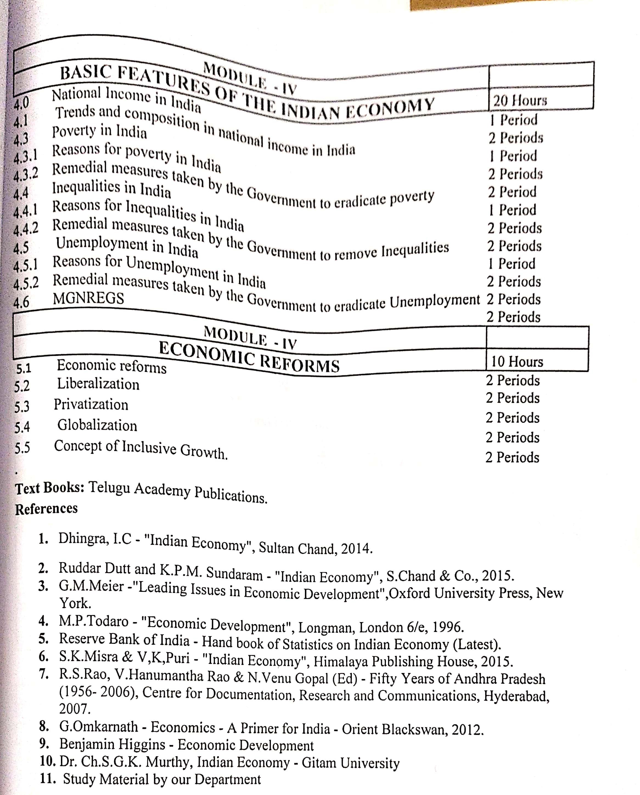

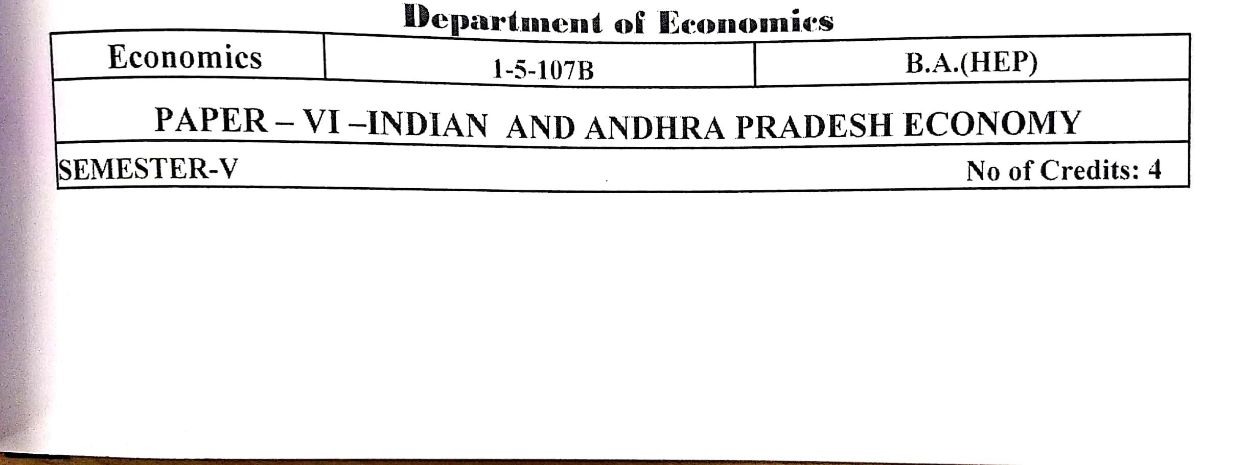

S.V. ARTS COLLEGE TIRUPATI

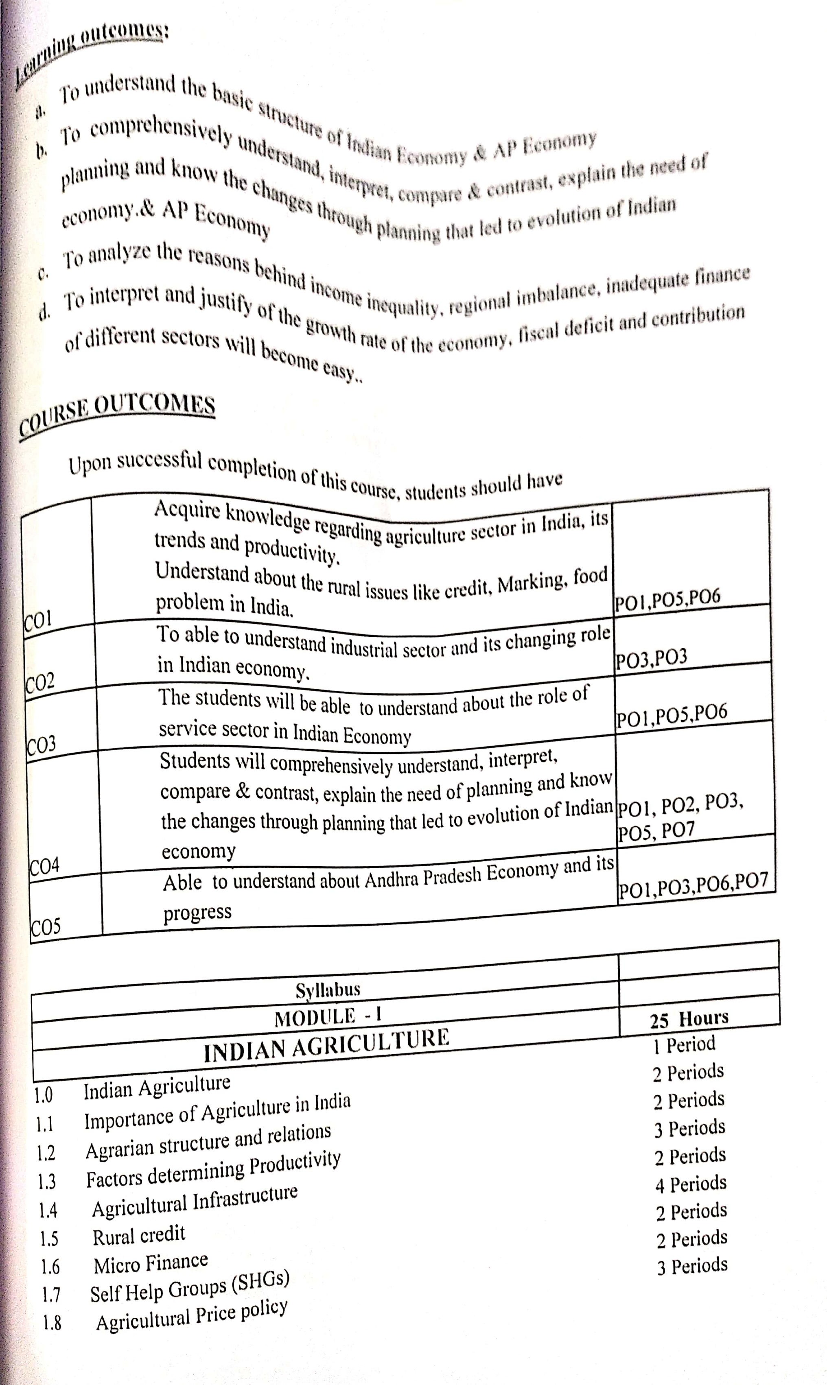

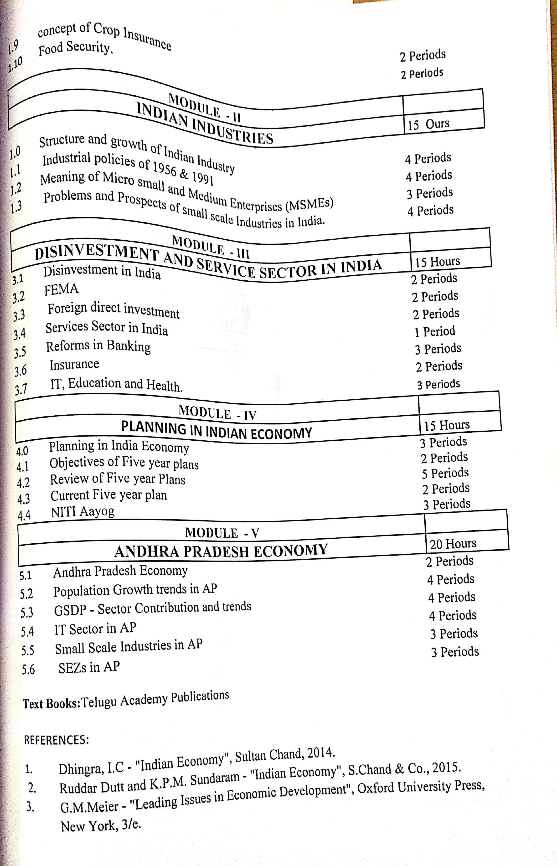

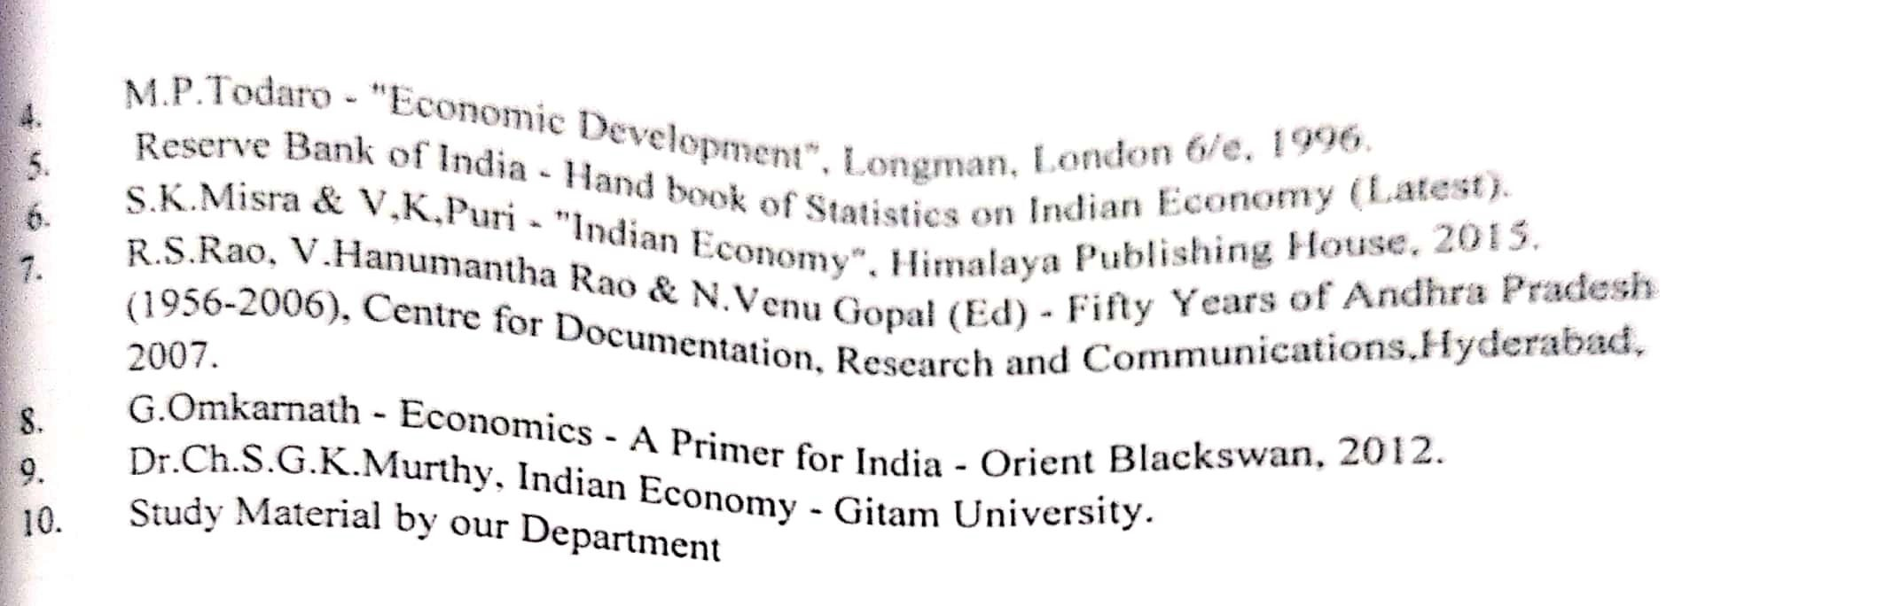

S.V. ARTS COLLEGE TIRUPATI
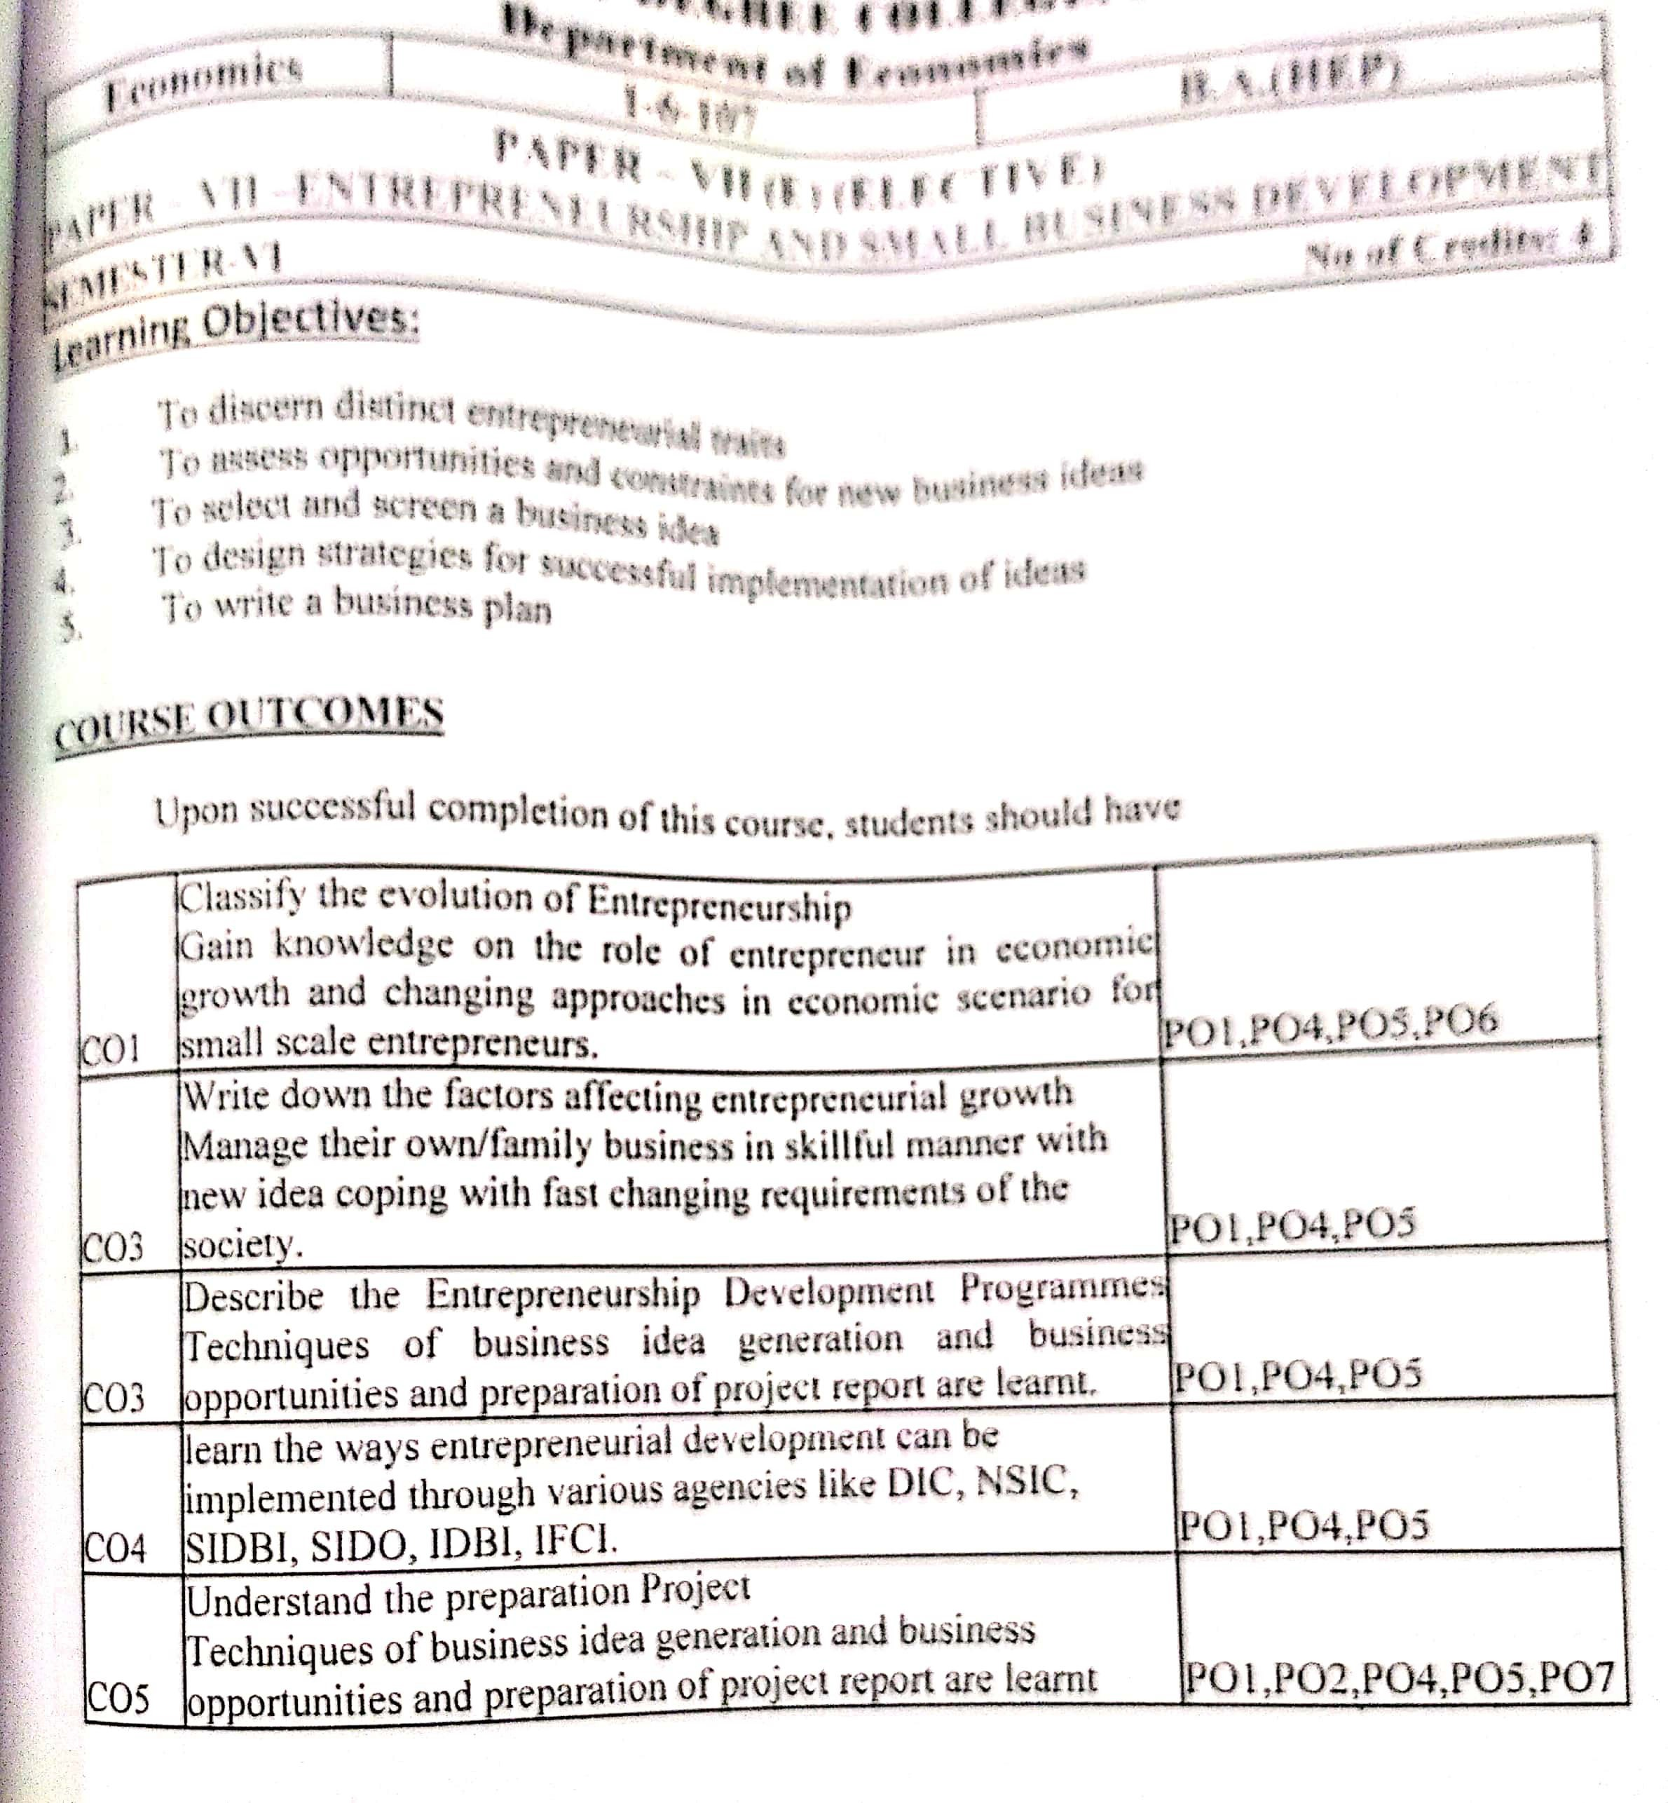DEPARTMENT OF ECONOMICS
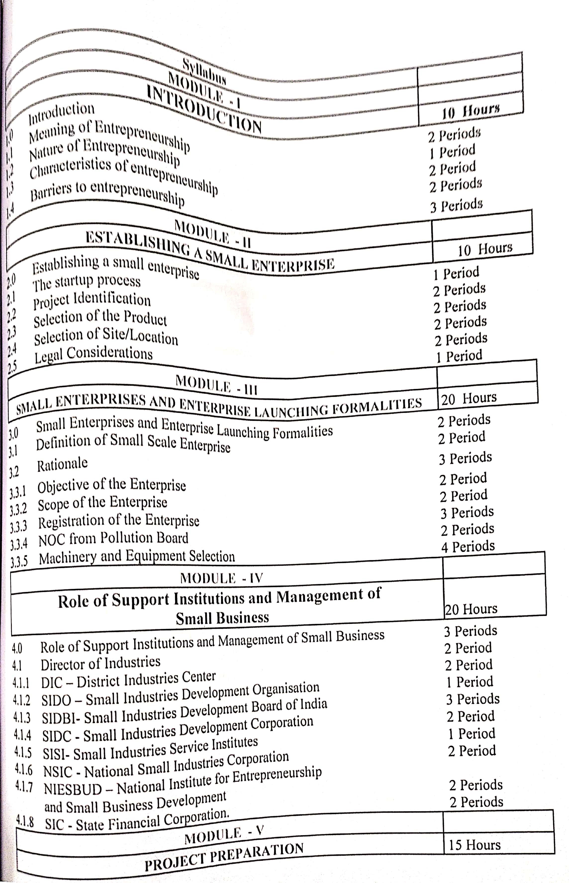

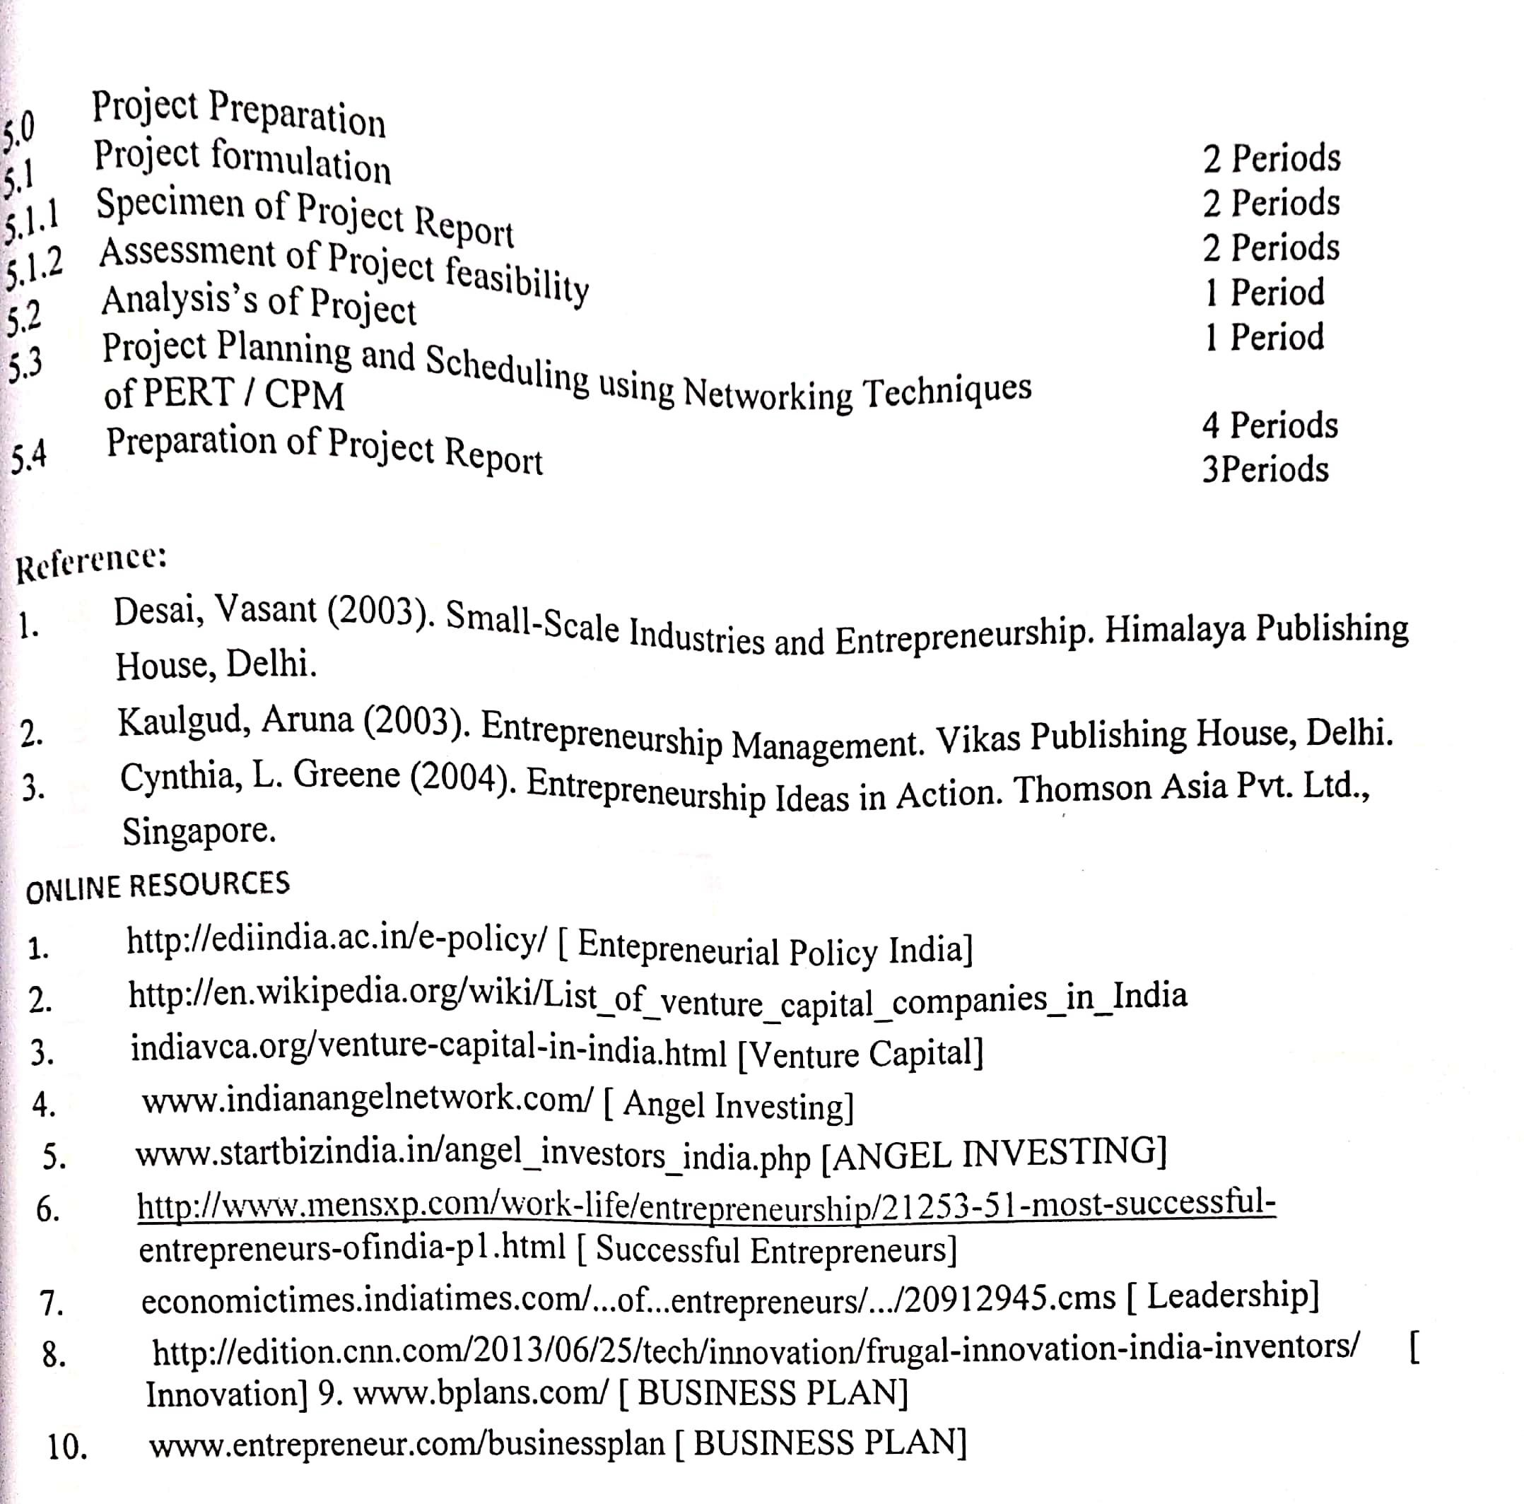

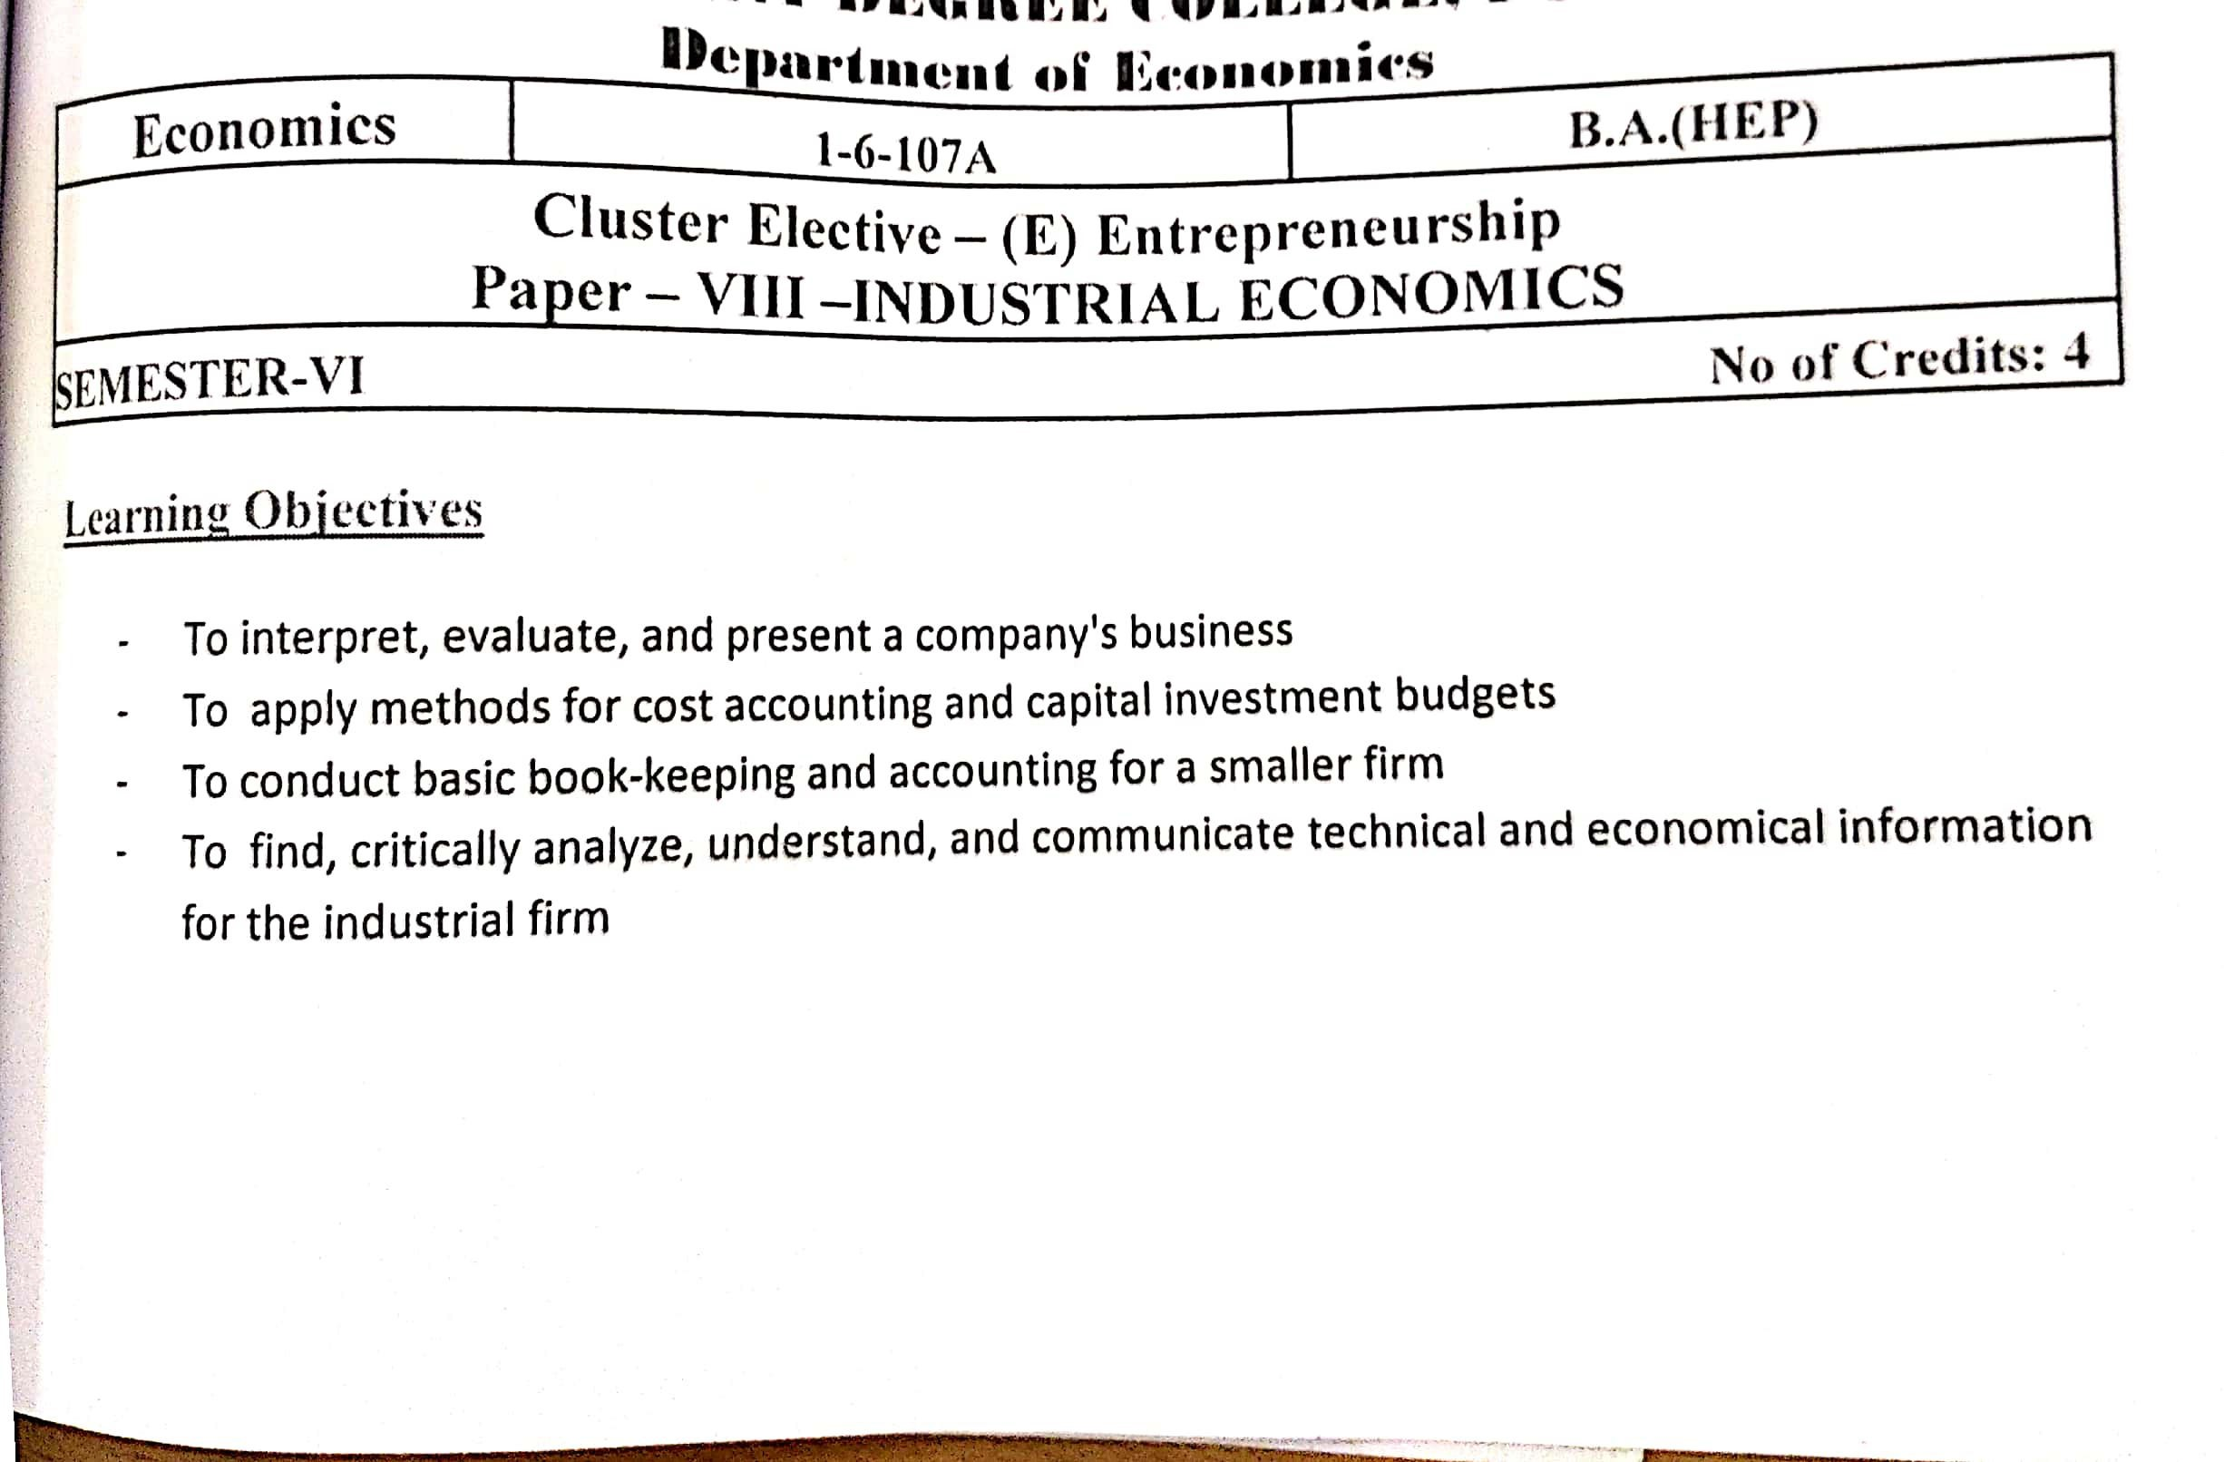

S.V. ARTS COLLEGE TIRUPATI
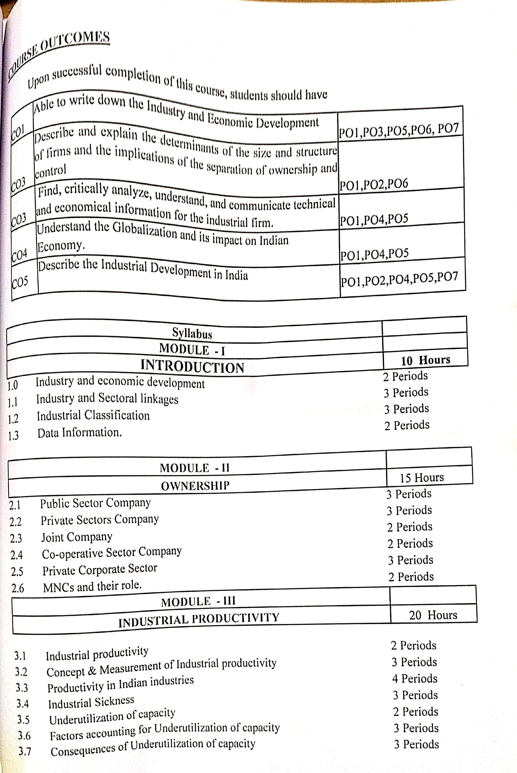

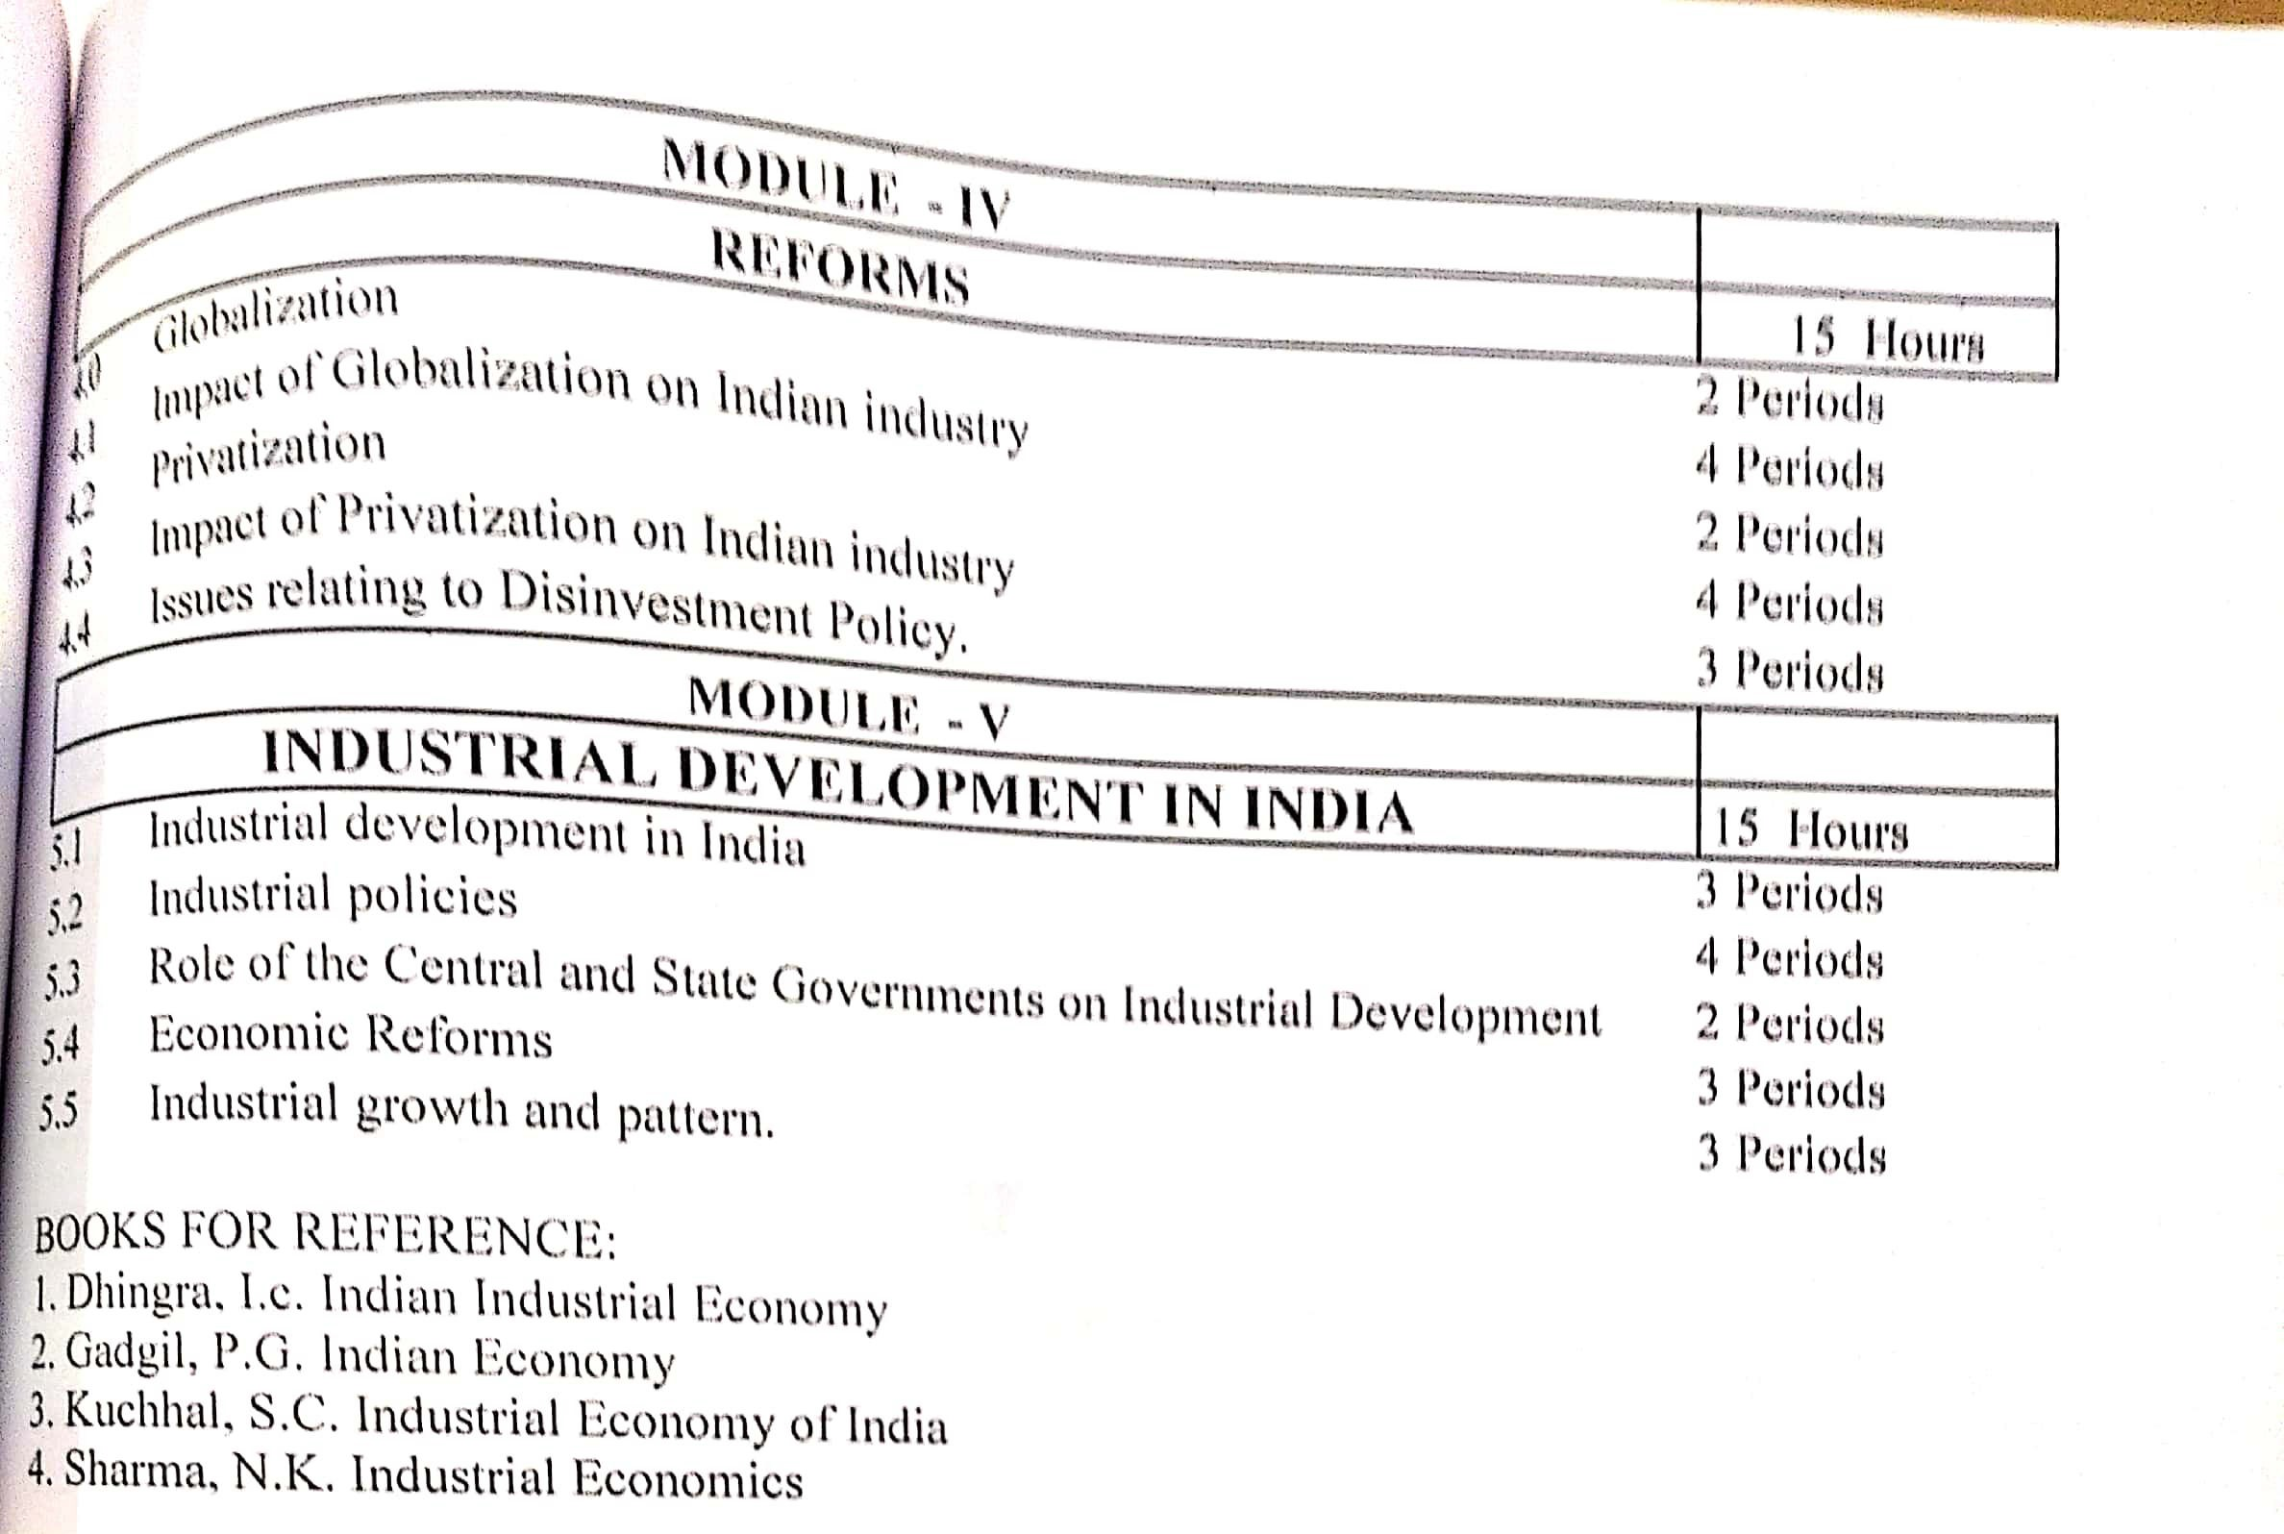

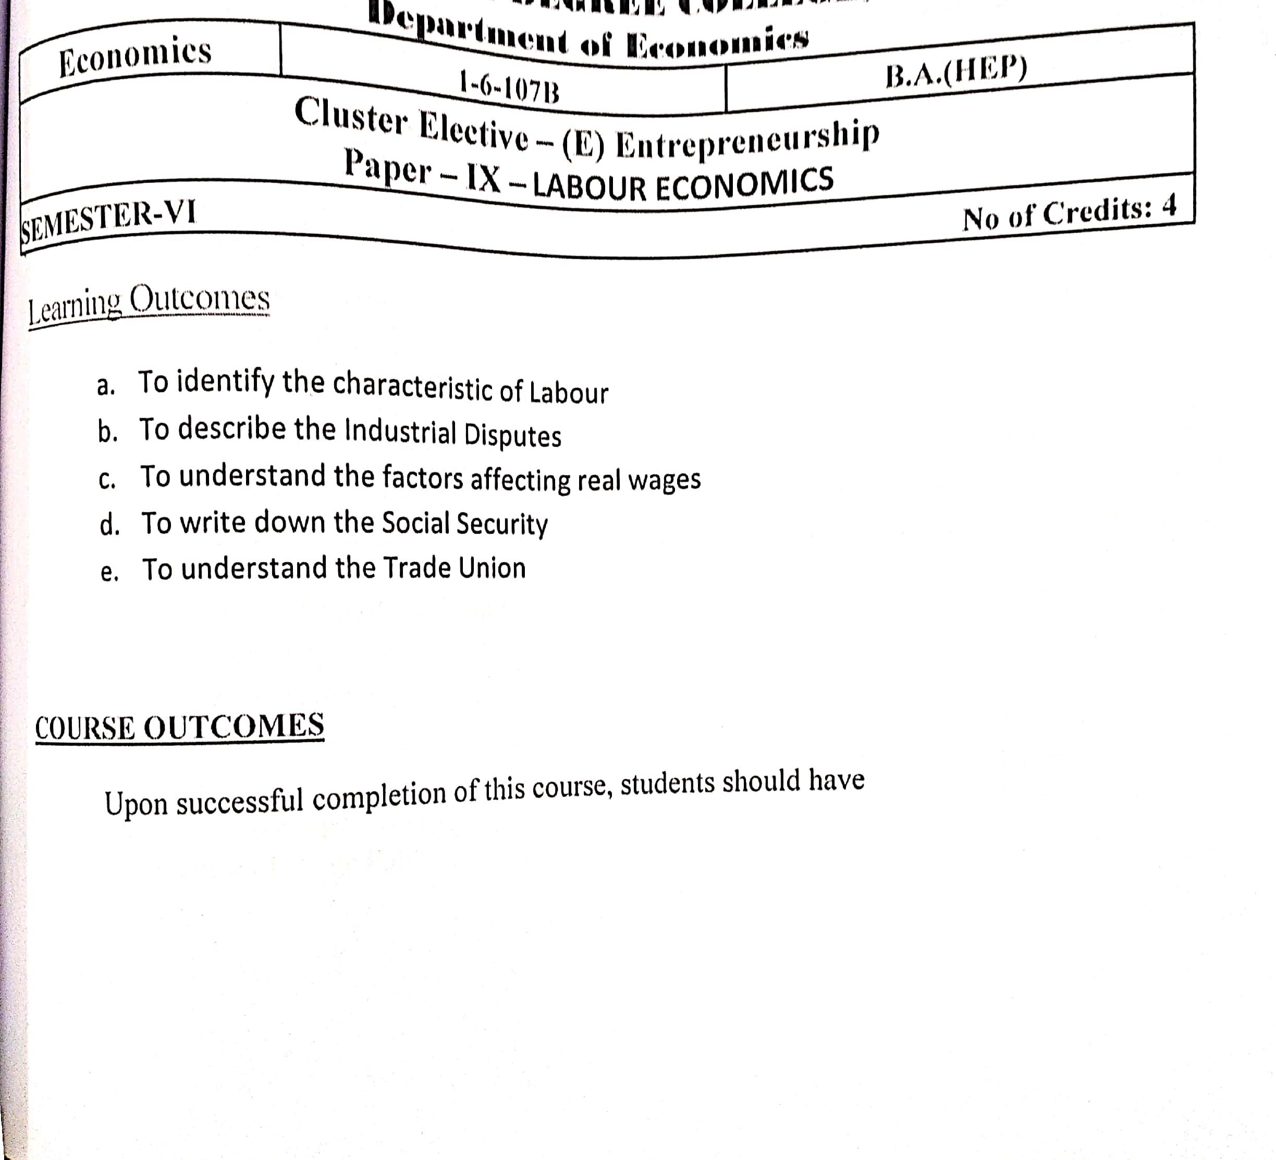
S.V. ARTS COLLEGE TIRUPATI
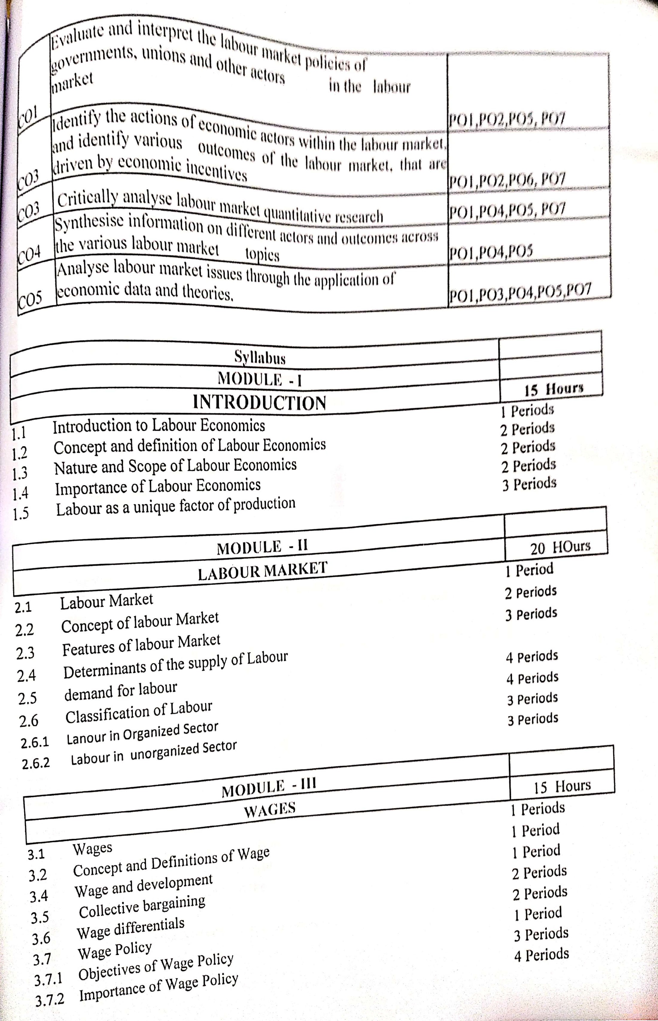

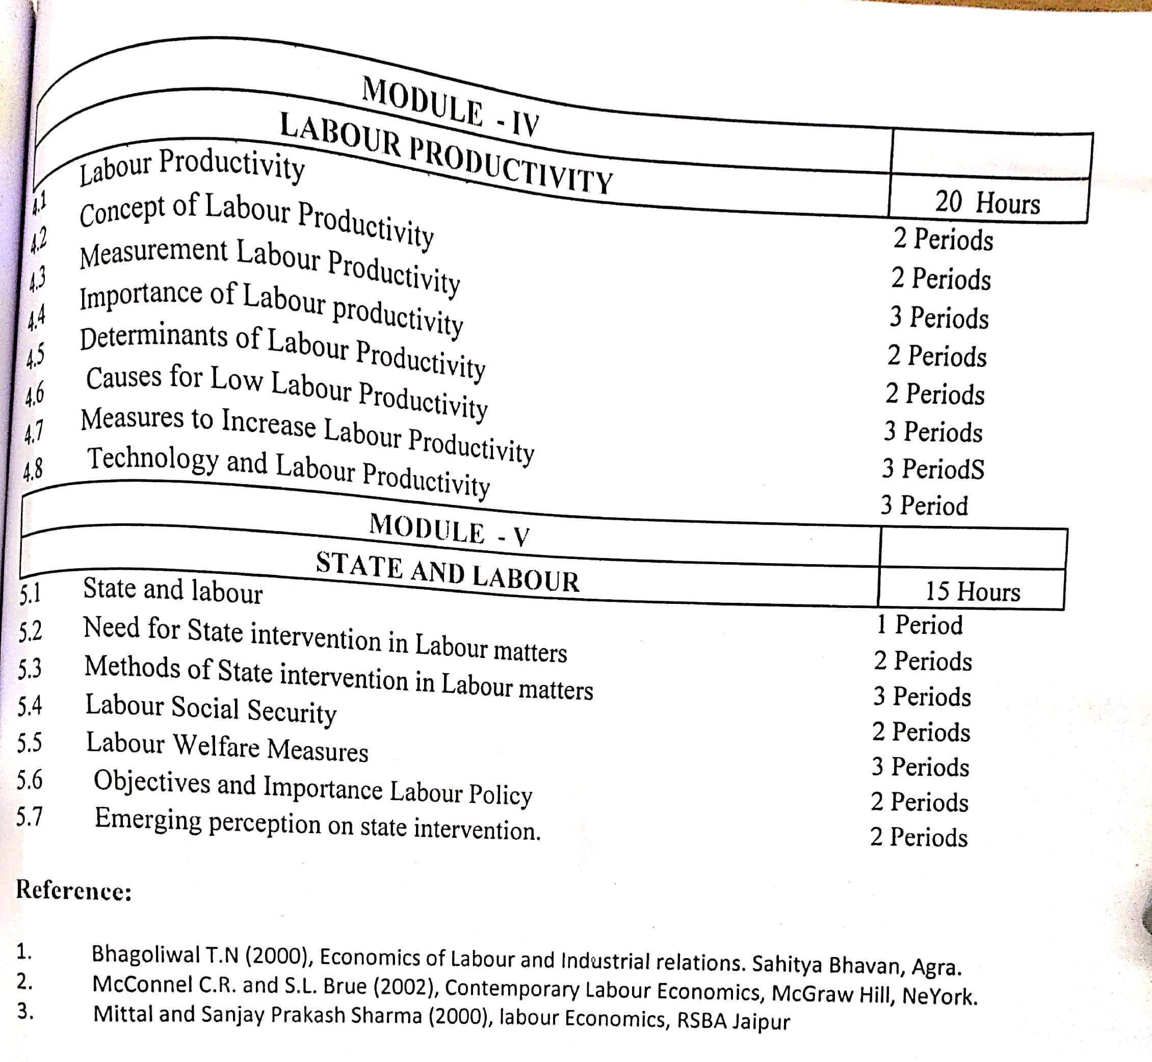

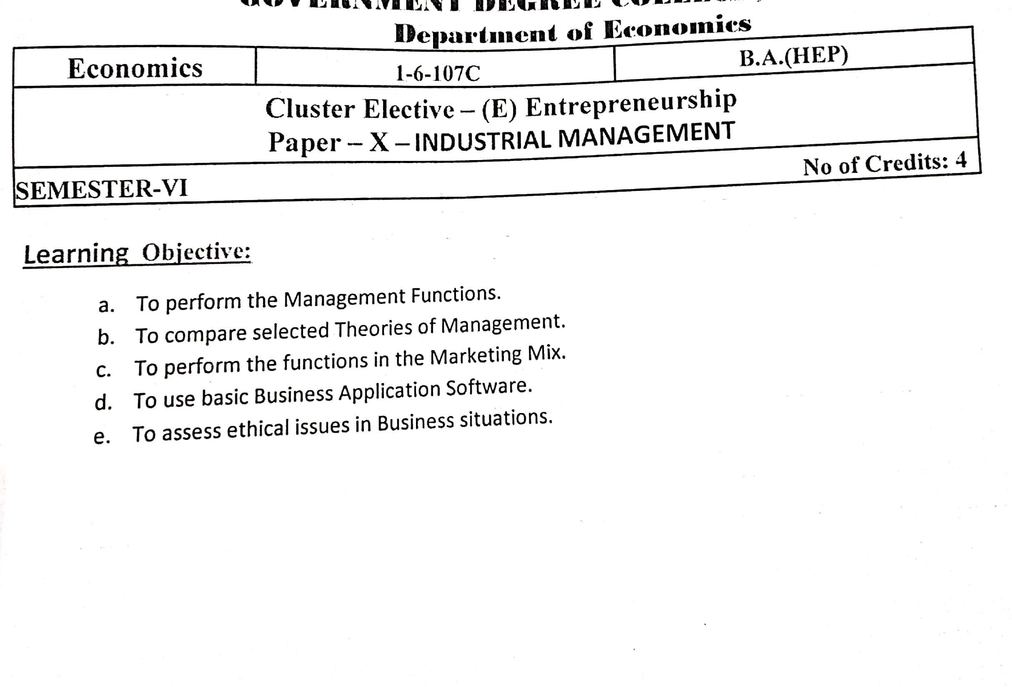

S.V. ARTS COLLEGE TIRUPATI
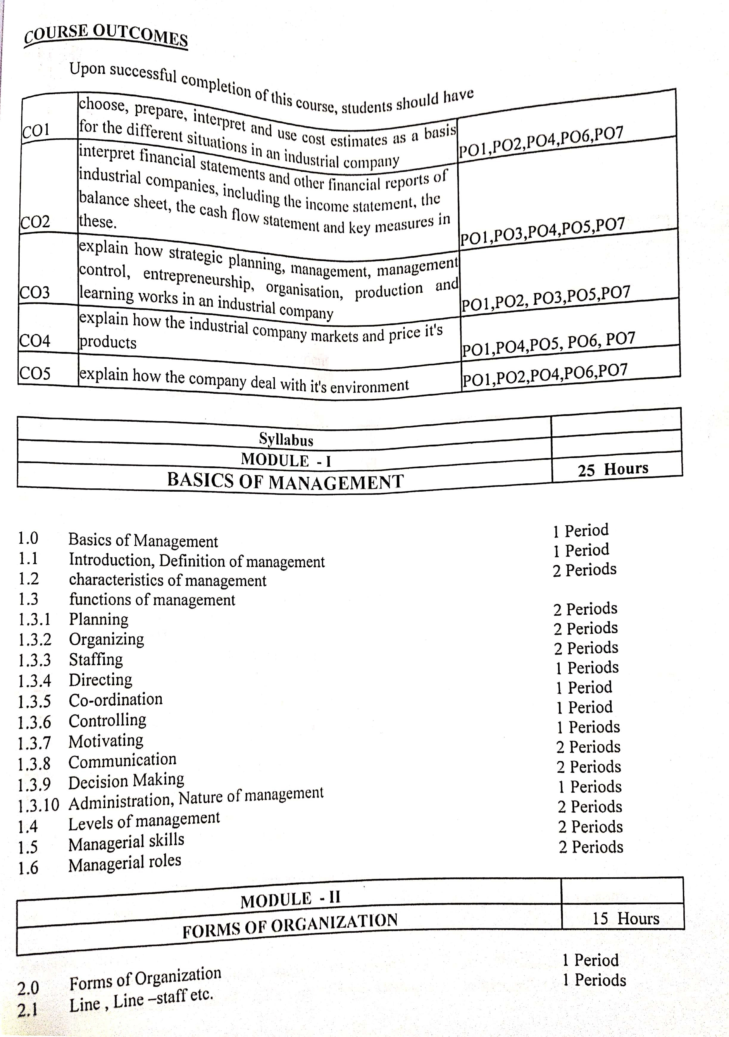

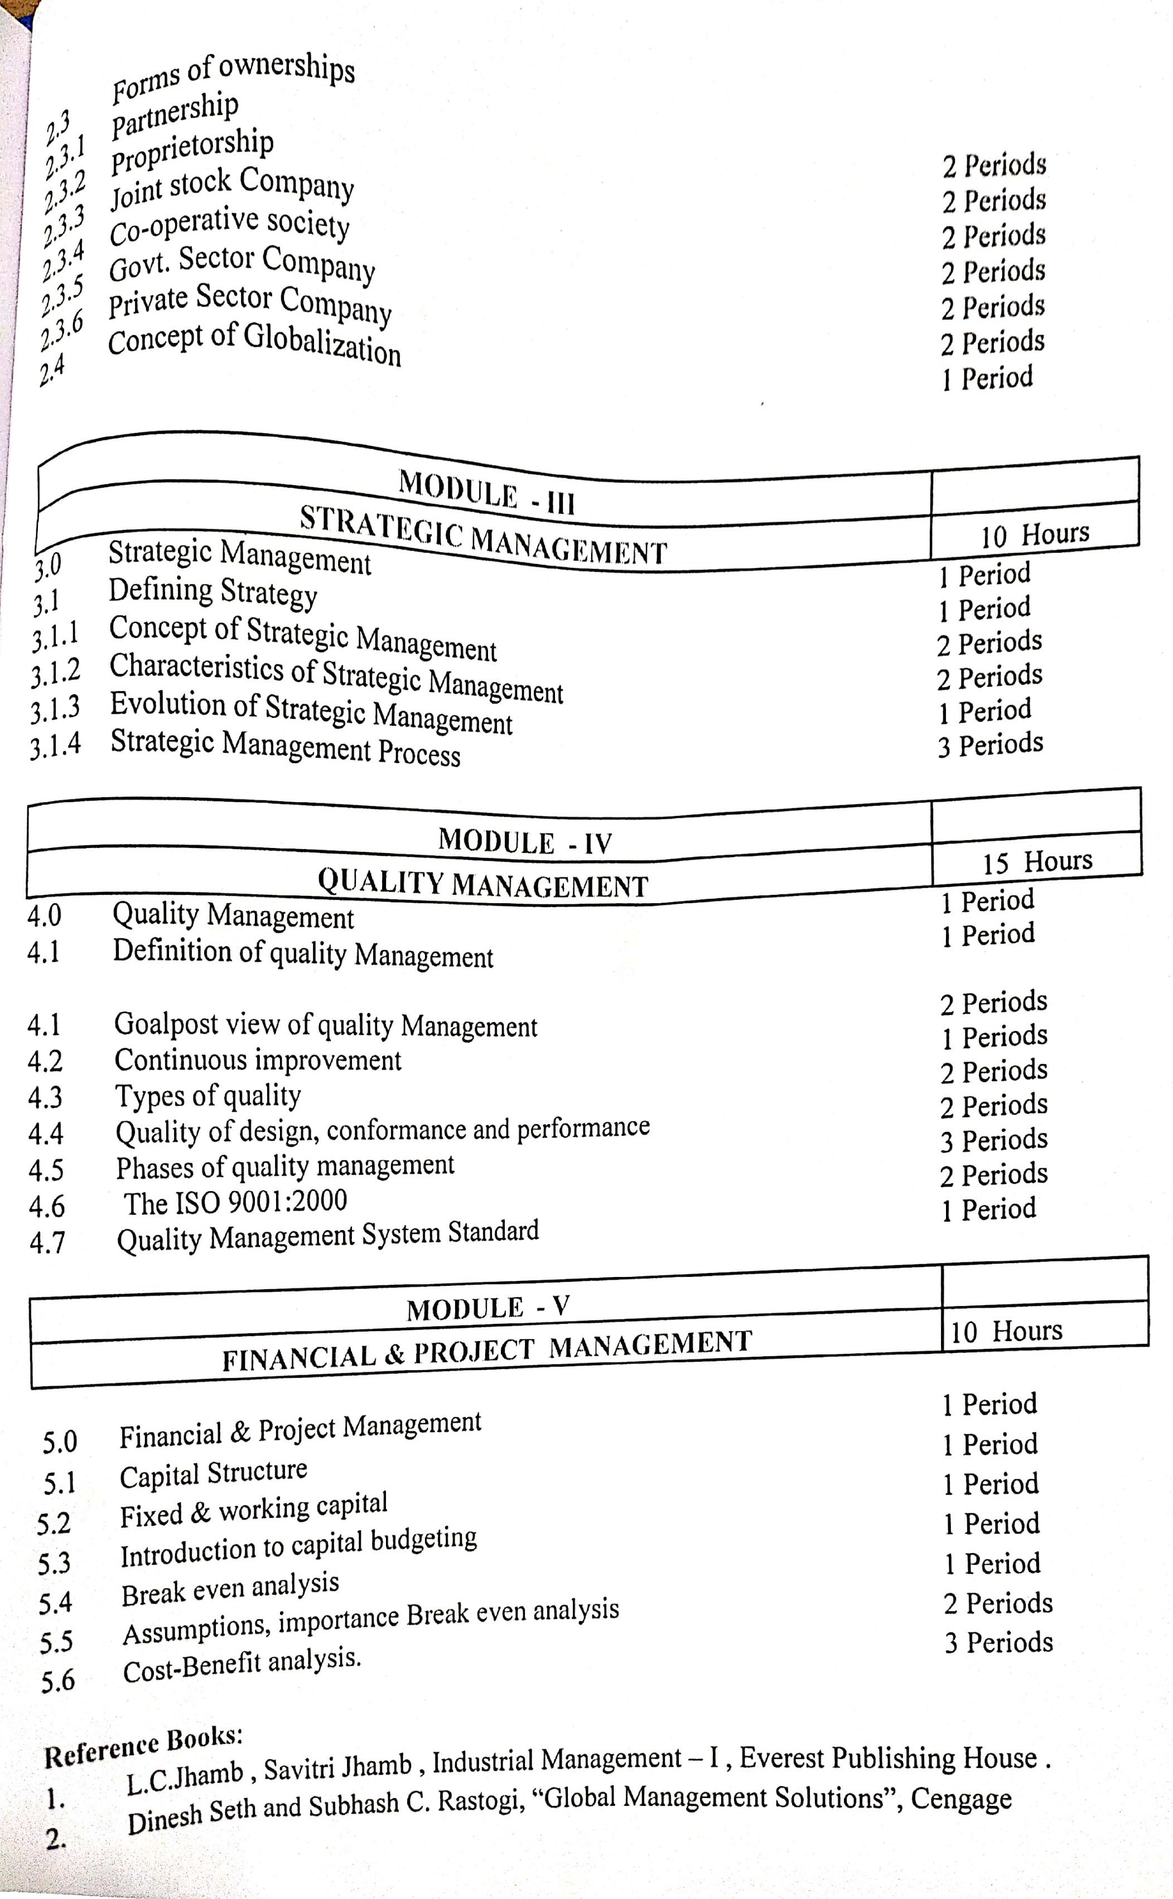

S.V. ARTS COLLEGE TIRUPATI
DEPARTMENT OF ECONOMICS
ECONOMICS (UG) SYLLABUS & COURSE LEARNING OUT COMES w.e.f. 2020-21
For Semesters I to IV Revised
Course Structure
SEM | COURSE | TITLE OF THE COURSE | Hrs/ Wk | Credits | Marks
I | 1 | Microeconomic Analysis | 5 | 4 | 100
II | 2 | Macroeconomic Analysis | 5 | 4 | 100
III | 3 | Development Economics | 5 | 4 | 100
IV | 4 | Economic Development in India and Andhra Pradesh | 5 | 4 | 100
IV | 5 | Statistical Methods for Economics | 5 | 4 | 100

